**CIS 544**

**Final Report**

**Dr. Cyrus Azboard**

**April 25, 2022**

**Anthony Ho, Hemen Hagos, Hyesu Lee, Marcho Handoko, and Zelalem Denekew**

# Table of Contents

Member …………………….…………………….…………………….…………………….……………………. 3

Project Management …………………….…………………….…………………….………………………. 4

Project Planning …………………….…………………….…………………….……………………. 4

Backlog …………………….…………………….…………………….…………………….…………… 5

Progress …………………….…………………….…………………….…………………….………….. 6

Data Models …………………….…………………….…………………….………………………….. 7

Project …………………….…………………….…………………….…………………….………………………. 17

Appendix …………………….…………………….…………………….…………………….………………… 105

Member Resume …………………….…………………….…………………….………………… 105

Files …………………….…………………….…………………….…………………….………………. 105

# Members

**Anthony Ho**

Major: Management Information System

**Hemen Hagos**

Major: Data Science, MS

**Hyesu Lee**

Major: Data Science, MS

**Marcho Handoko**

Major: Data Science, MS

**Zelalem Denekew**

# Major: Data Science, MS

# Project Management

## **Project Planning**

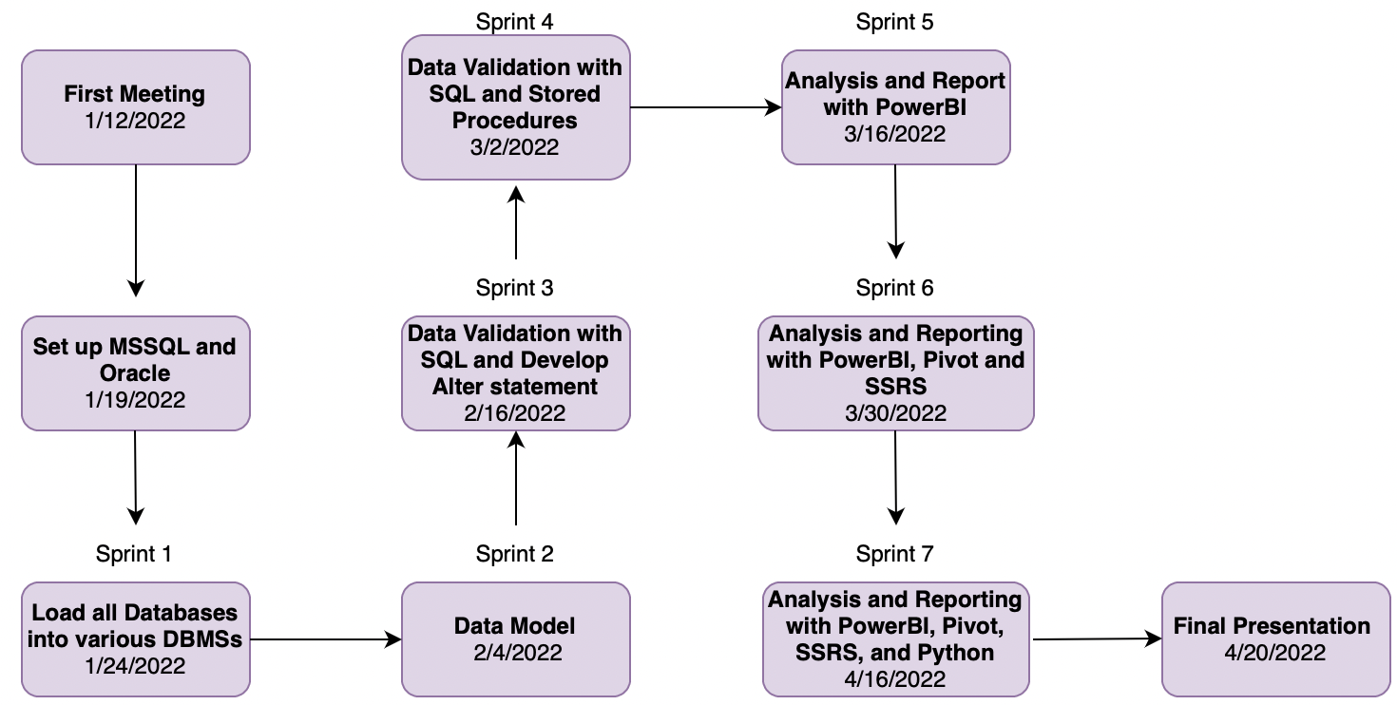

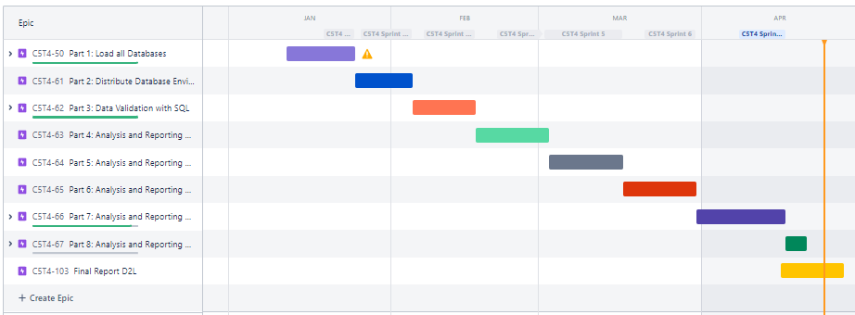

## **Backlog**

Sprint 1

* Set up Oracle and MSSQL
* ​Convert MSSQL Version of DGDB into ORACLE​
* Load all databases in various DBMS​
* Create a Burndown chart​, Pert chart, and Gantt ​
* Manage Jira Board​​
* Create presentation
* Create video presentation

Sprint 2

* Data Model
* Developing Alter Statements
* Developing a list of databases
* Developing all the charts
* Developing the PowerPoint Presentation and Video Presentation

Sprint 3

* + Developing ALTER Statements
  + Writing Queries on MSSQL
  + Developing all the charts
  + Developing the PowerPoint Presentation and Video Presentation

Sprint 4

* + Writing Stored Procedures
  + Writing UDF
  + Validate the Database on Docker Server
  + Developing the PowerPoint Presentation and Video Presentation
  + Running Queries on DOCKER

Sprint 5

* Create Power BI visualizations ​
* Validate the visualized data with the Database used​
* Finalize data validations for our databases​
* Developing the PowerPoint Presentation and Video Presentation​
* Develop queries (code) based on the examples provided in class​

Sprint 6

* Create Power BI visualizations for all available databases and DGDB​
* Create PIVOT tables for all available Databases and DGDB​
* Create SSRS reports for all available databases and DGDB​
* Cross validates the reports and visualizations ​
* Cross validates the reports of databases with DGDB reports​
* Cross validates the visuals of databases with DGDB visuals​

Sprint 7

* Create queries/solutions for all provided Use Cases in both SQL server and Oracle DBMSs
* Create Visualizations of all the Use Cases using Powe BI​
* Create Visualizations of all the Use Cases using PIVOT Tables
* Create Visualizations of all the Use Cases using Python​
* Create reports of all the Use Cases using SSRS​
* Validate the visualized Data with the databases used and other databases provided (i.e., DGDB Vs. Individual DBs)​

## **Progress**

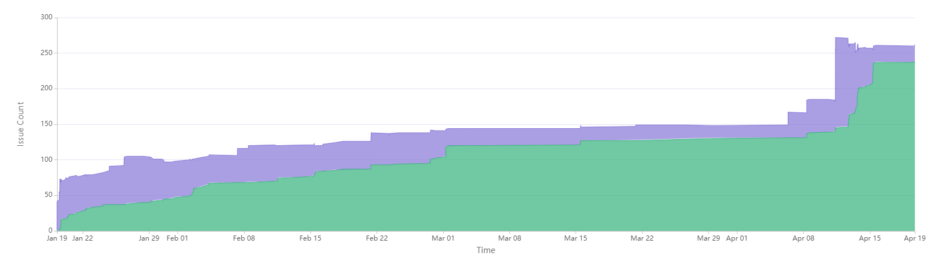

## **Data Models**

### Book

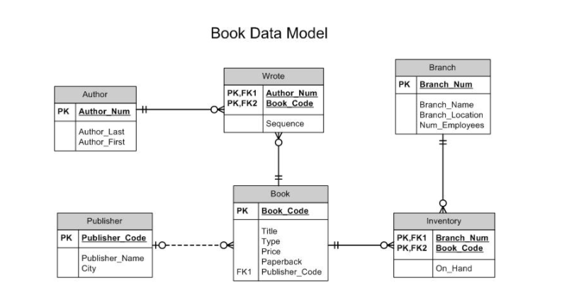

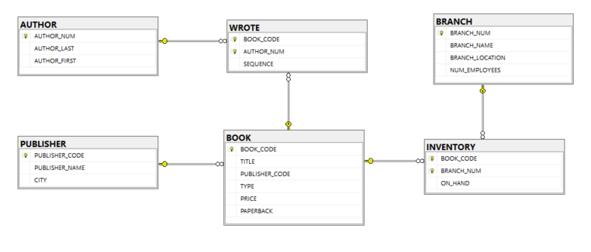

### Company

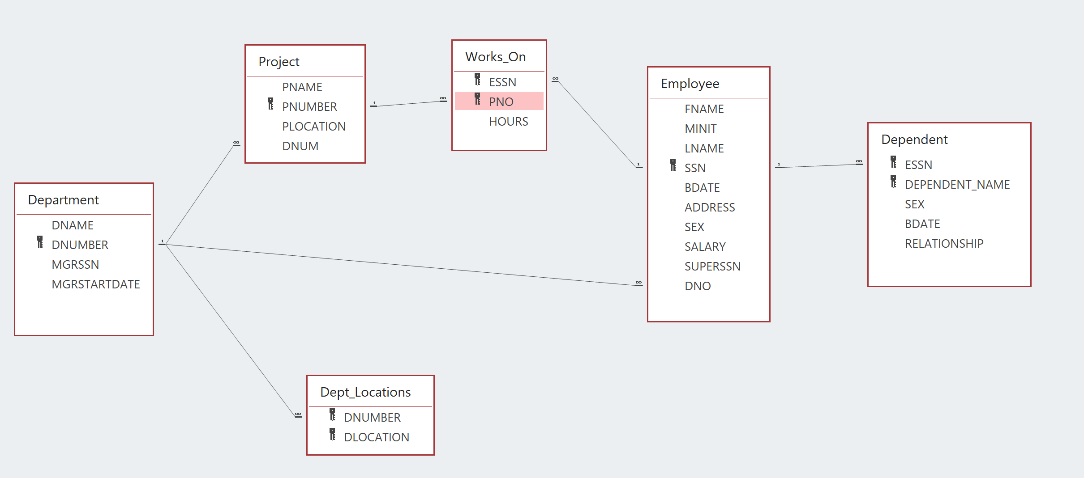

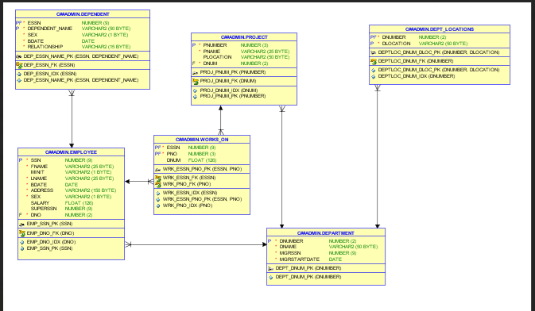

### SP

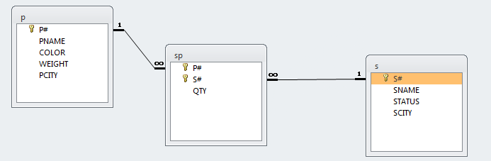

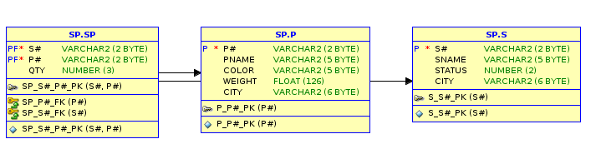

### Prop

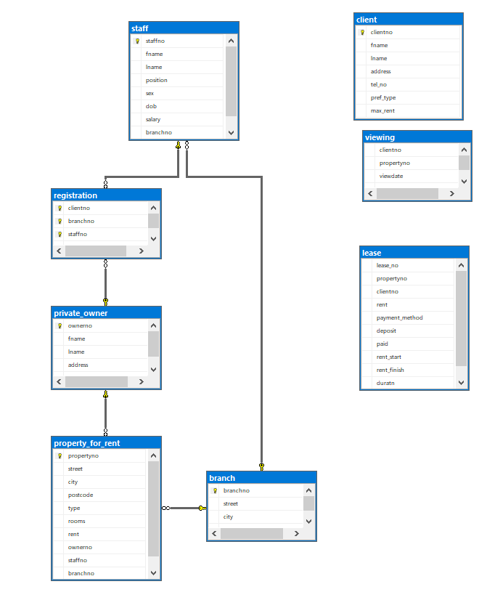

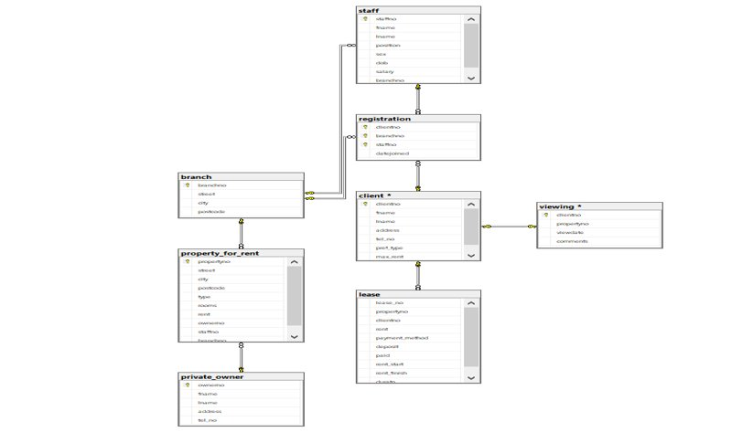

### OES

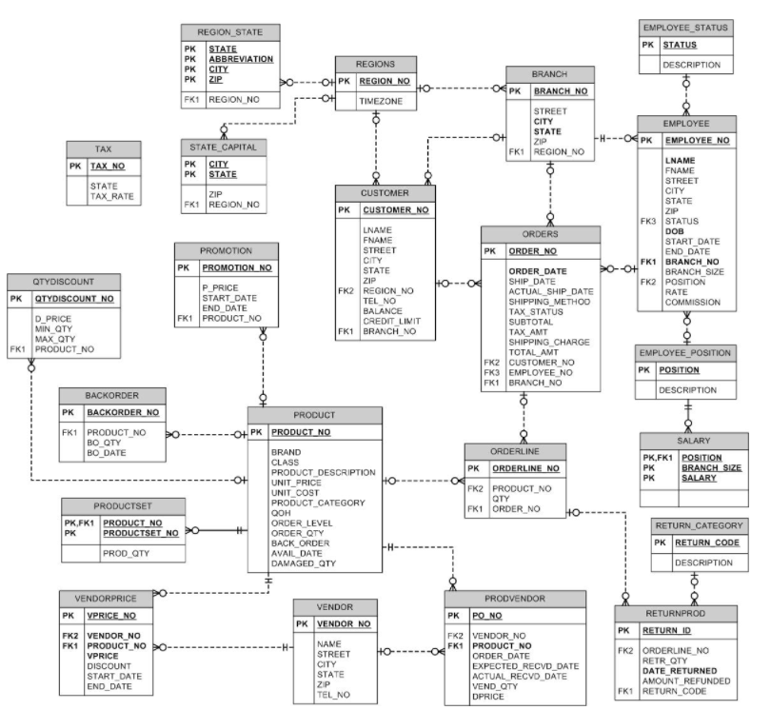

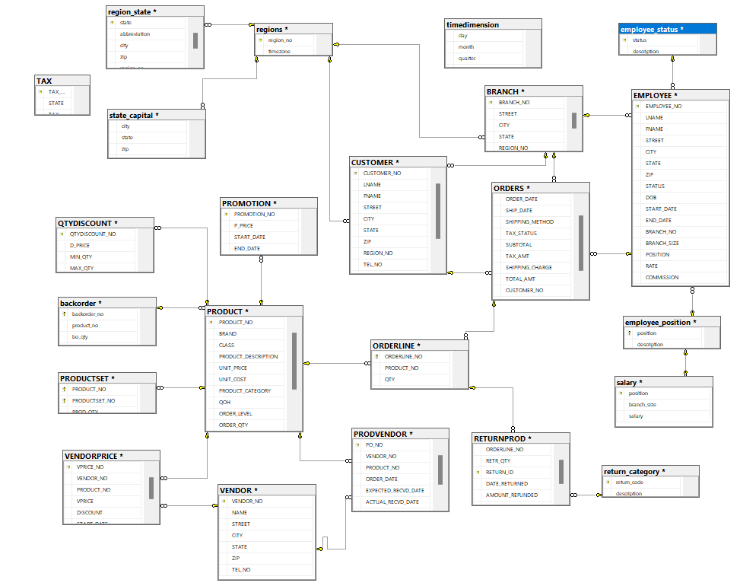

After Altered

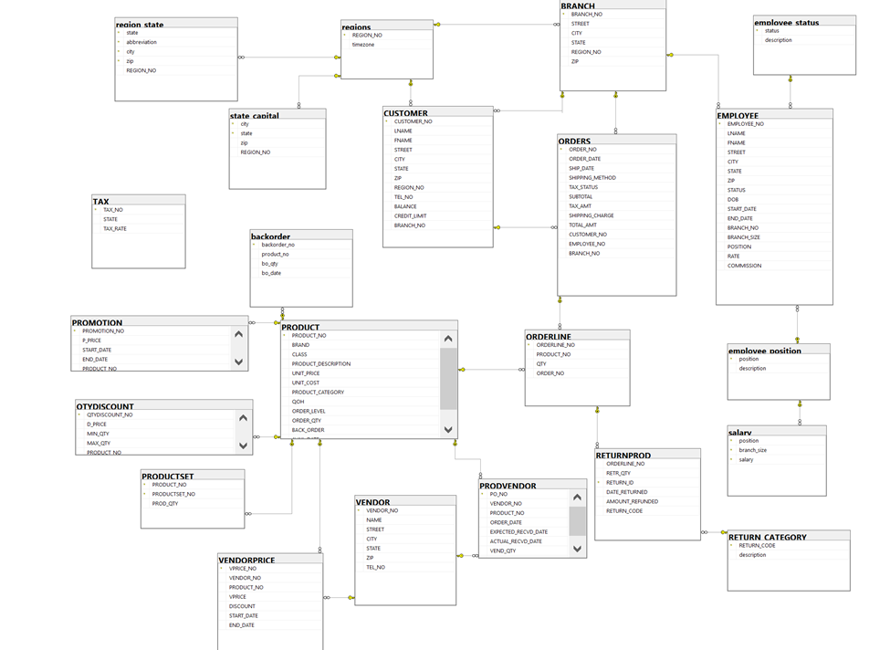

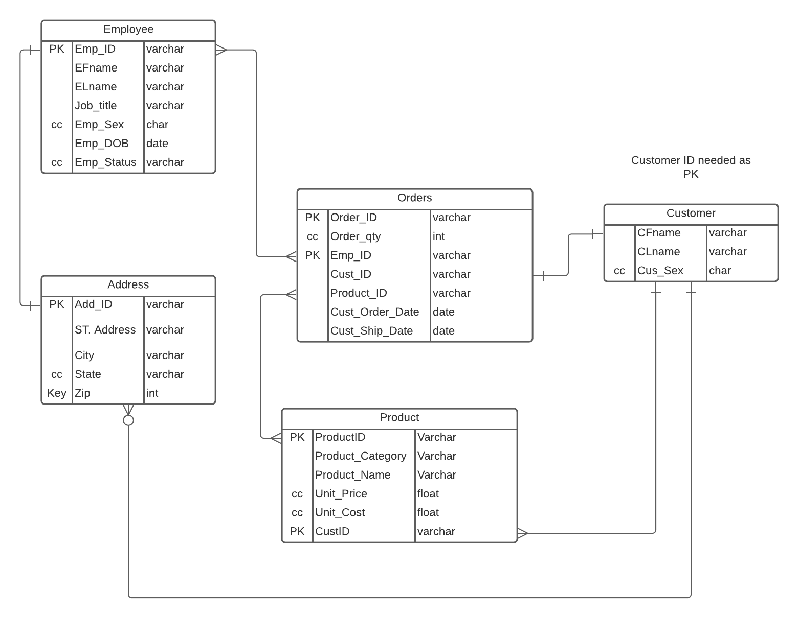

### Game

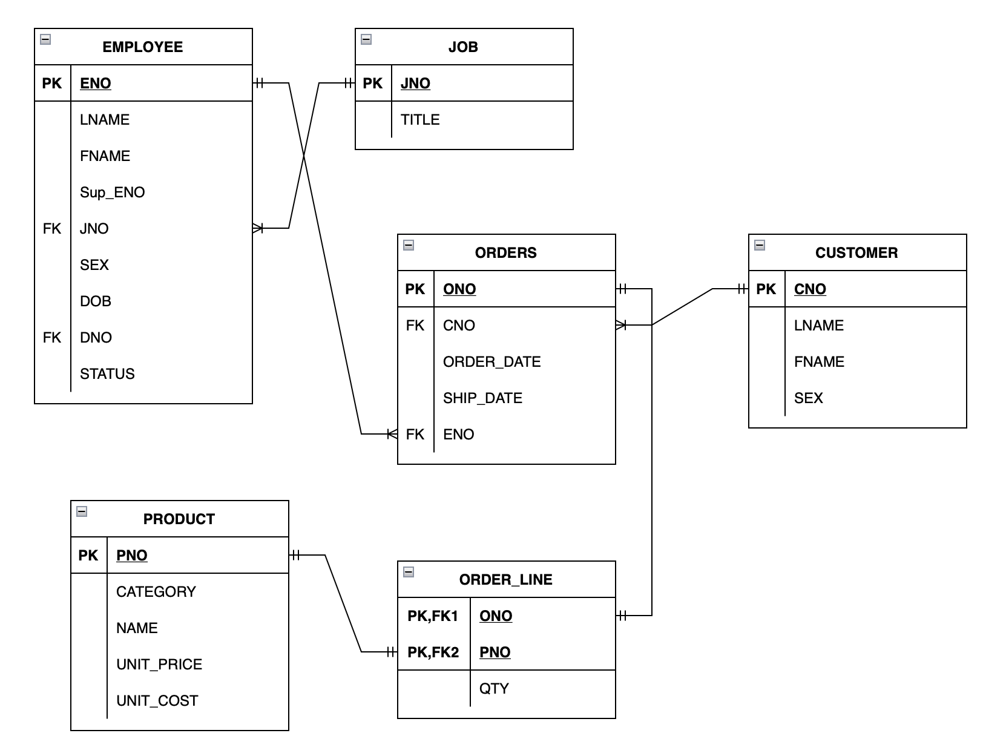

Furniture

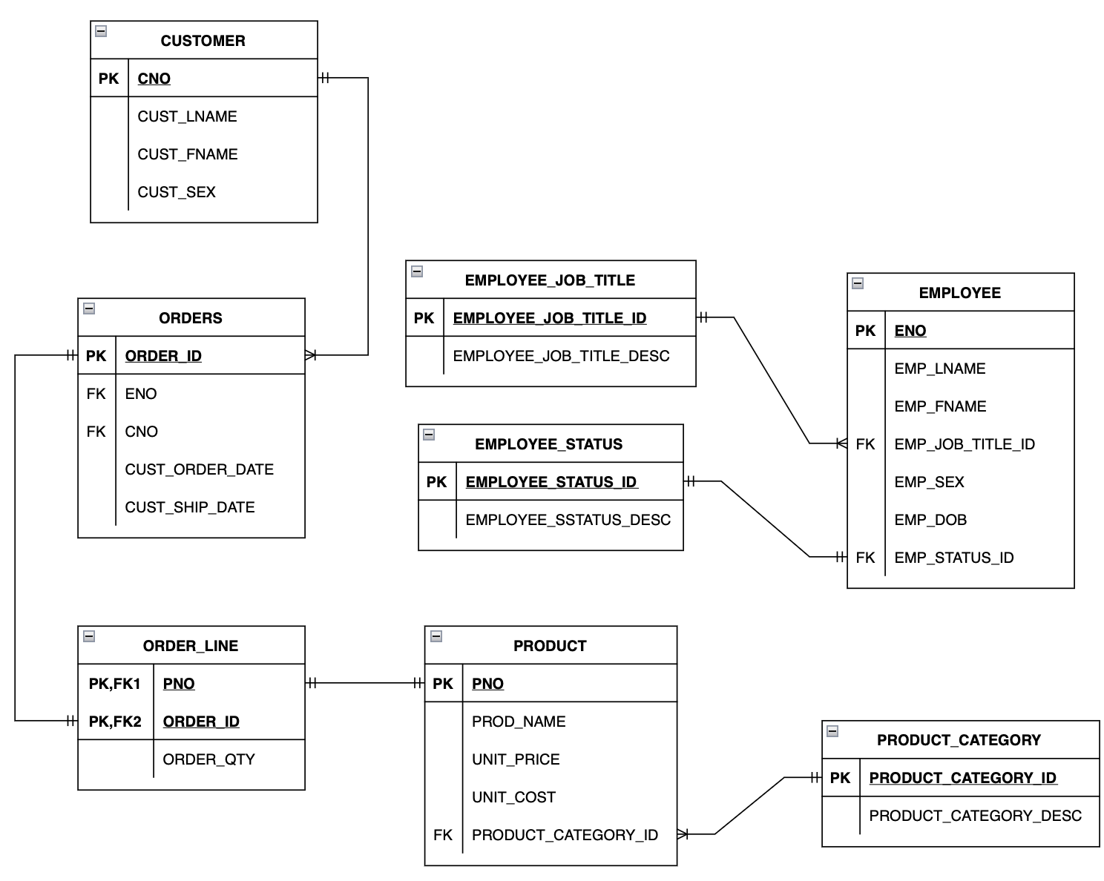

### SPJ2

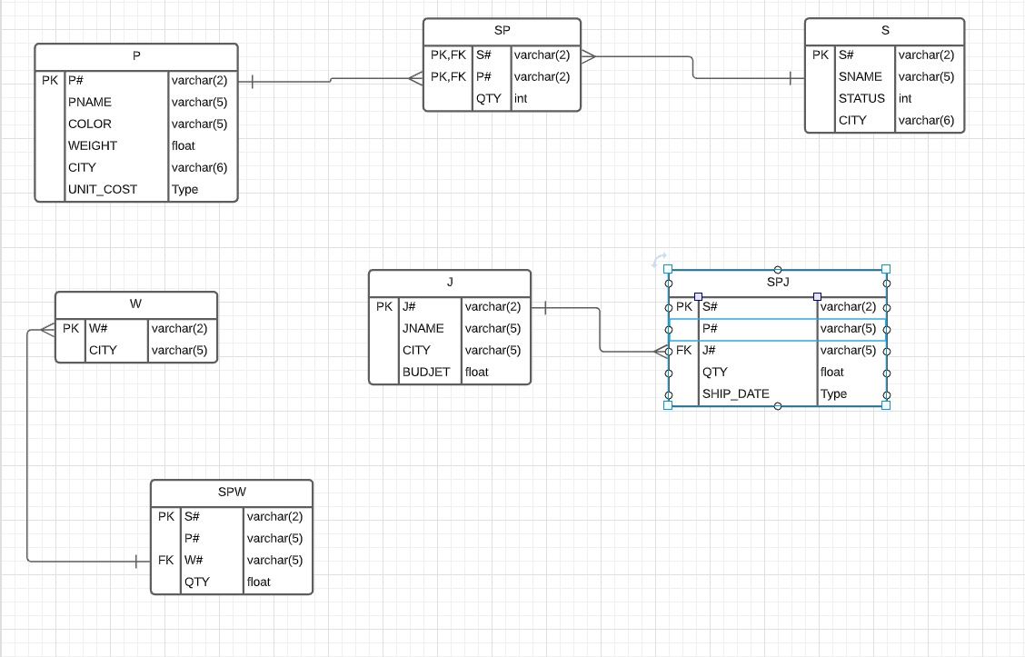

**Use Cases**

# 1. For every schema, list Schema, # tables, # records

## 1. For all MSSQL Schemas (Goal is to this in one program)

### a. **SQL**

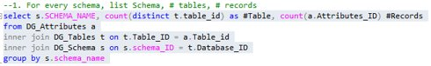

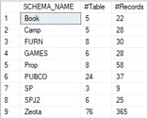

**Oracle**

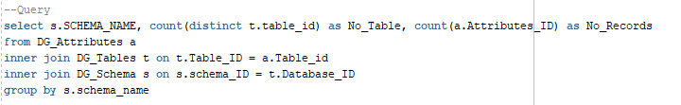

### b. **Procedure**

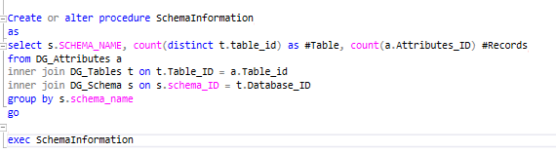

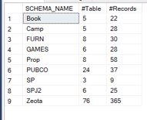

**Oracle**

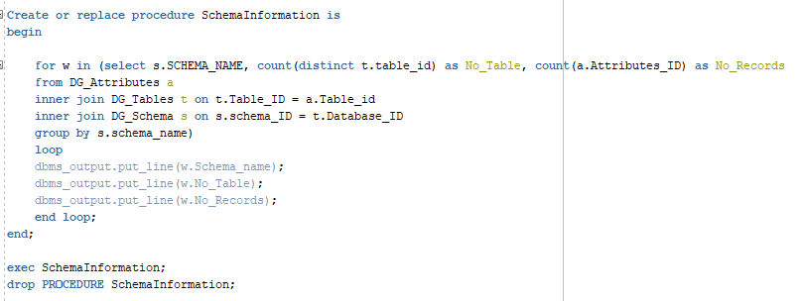

### c. **UDF**

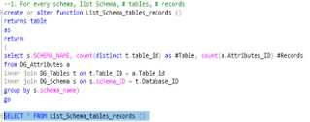

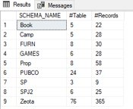

### e. **Pivot**

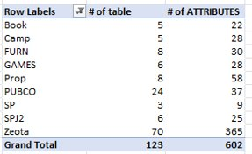

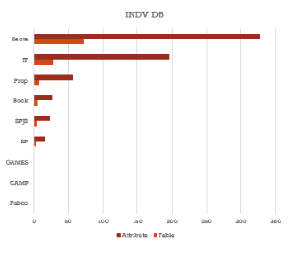

### f. **SSRS**

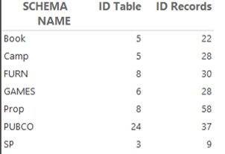

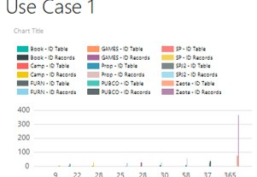

### g. **Power BI**

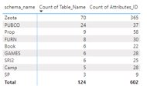

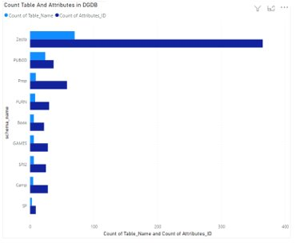

### h. **Python**

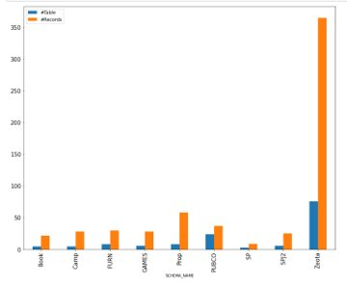

# 2. For every schema, list table name, # attributes,# PK_ attr, # FK_ attr, # NN_attr, # IDX_attr, # CC_attr, # UQ_attrs, # PGM_attr

## 1. For all MSSQL Schemas (Goal is to this in one program)

### a. SQL

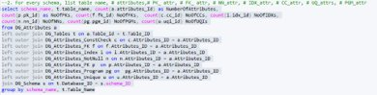

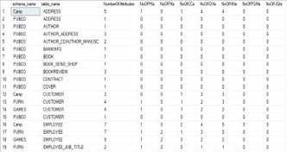

**Oracle**

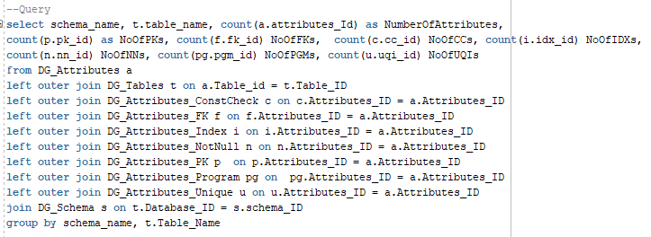

### b. Procedure

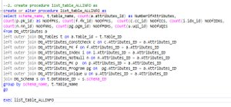

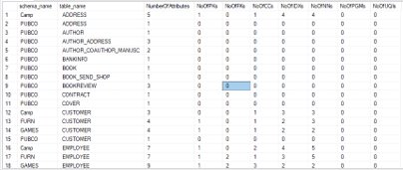

**Oracle**

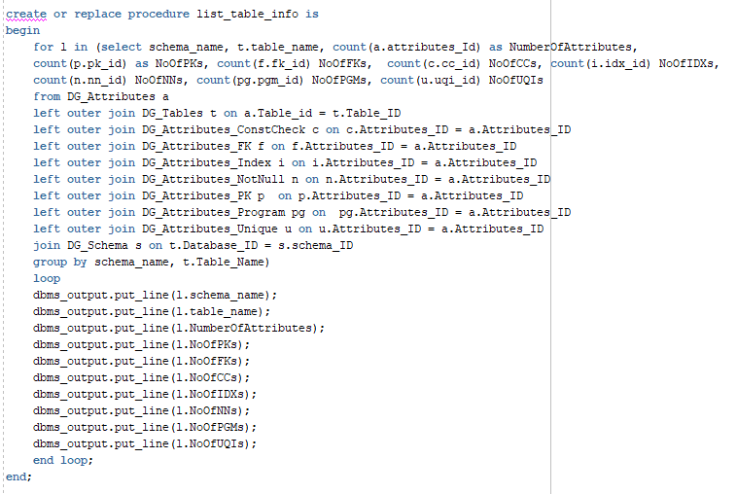

### c. UDF

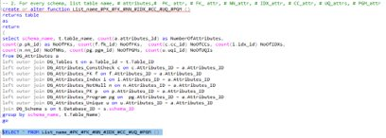

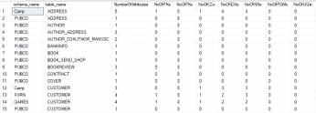

### e. Pivot

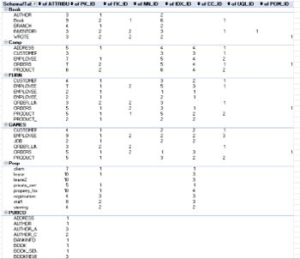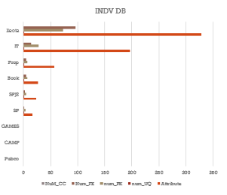

### f. SSRS

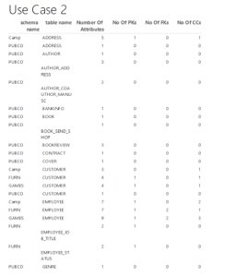

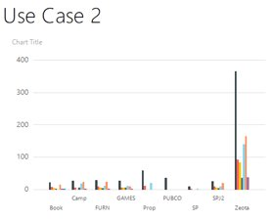

### g. Power BI

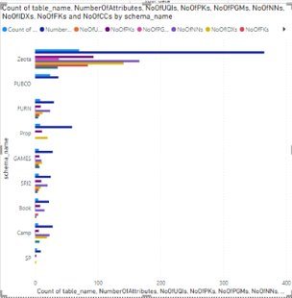

### h. Python

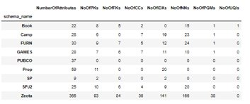

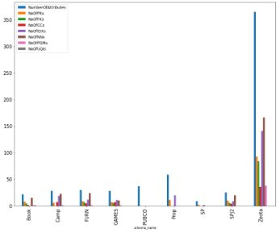

# 3. For every schema, list Table_ID, Table_Name, attribute_id, attribute_Name, PK_ID, FK_ID, NN_ID, constraint_type, and constraint_Name

### a. SQL

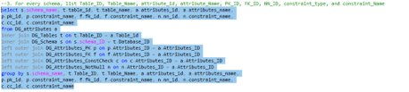

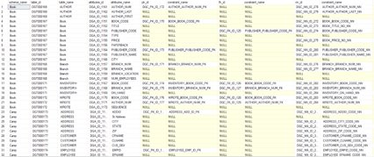

**Oracle**

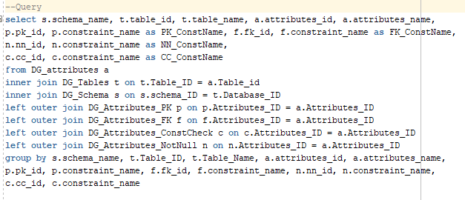

### b. Procedure

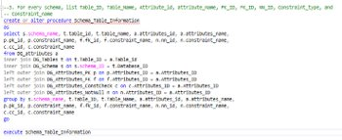

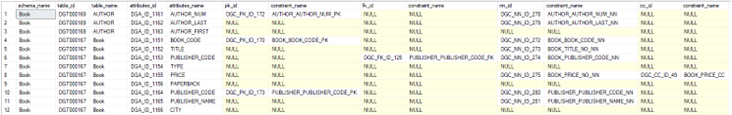

**Oracle**

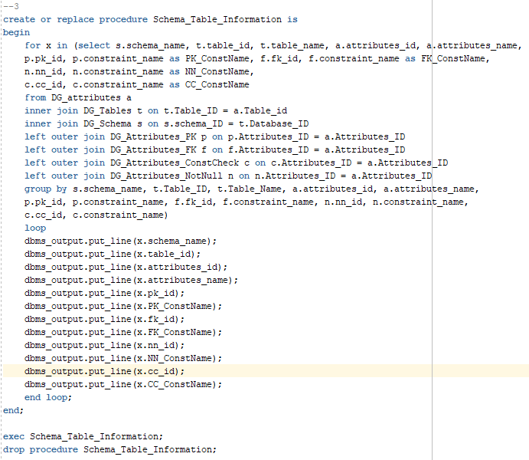

### c. UDF

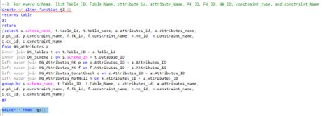

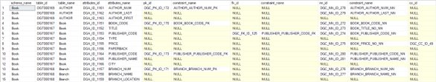

### d. Pivot

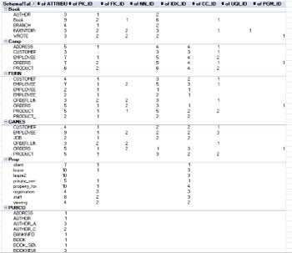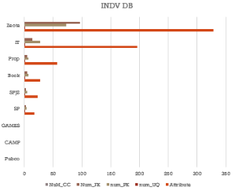

### e. SSRS

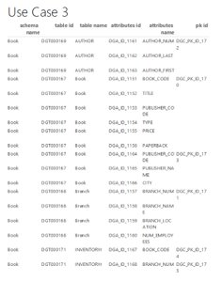

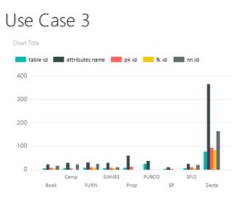

### f. Power BI

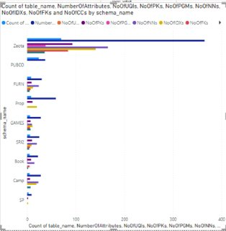

### g. Python

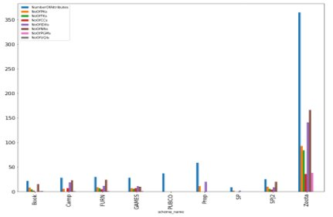

# 4. For every schema, list tables with PK but without FK and IDX

### a. SQL

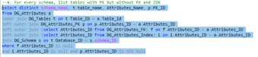

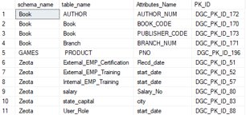

**Oracle**

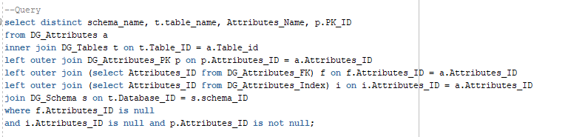

### b. Procedure

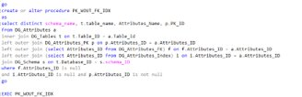



**Oracle**

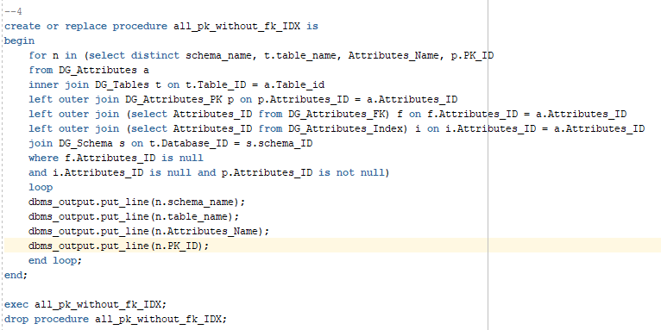

### c. UDF

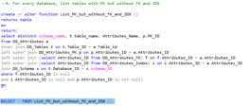

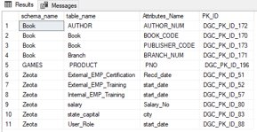

### e. Pivot

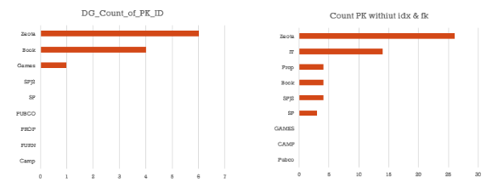

### f. SSRS

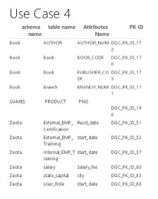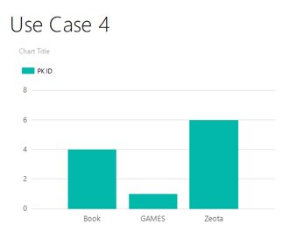

### g. Power BI

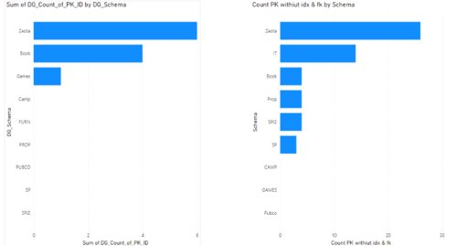

### h. Python

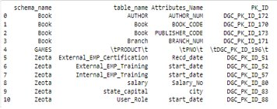

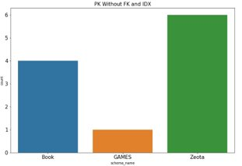

### 

# 5. For every database/schema, rank them according to number of NN (Not Null) have created

## 1. For all MSSQL Schemas (Goal is to this in one program)

### a. SQL

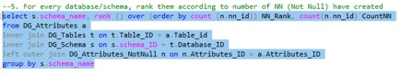

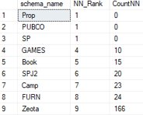

**Oracle**

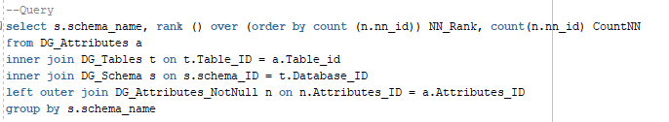

### b. Procedure

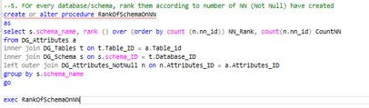

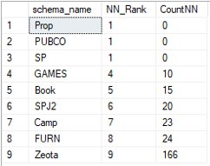

**Oracle**

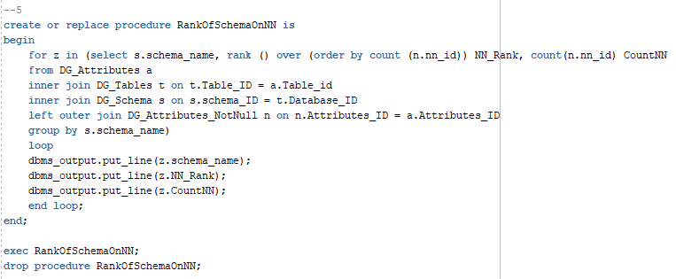

### c. UDF

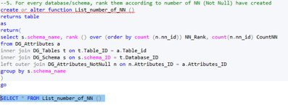

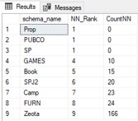

### e. Pivot

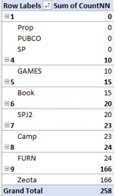

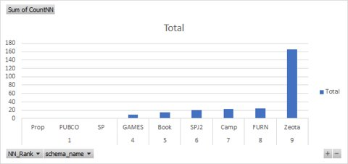

### f. SSRS

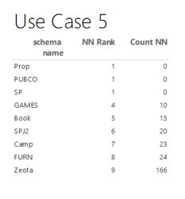

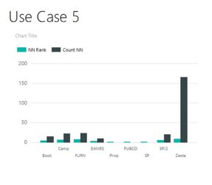

### g. Power BI

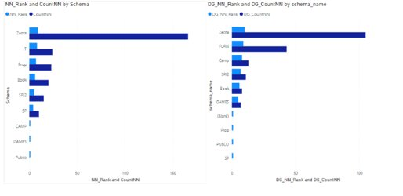

### h. Python

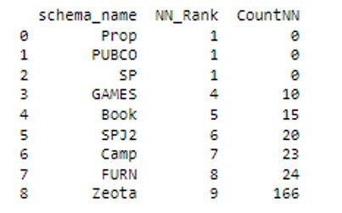

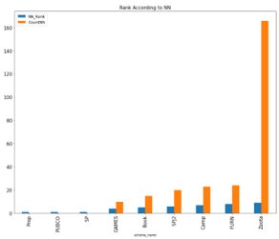

## 

# 6. For every database, list tables without PK

## 1. For all MSSQL Schemas (Goal is to this in one program)

### a. SQL

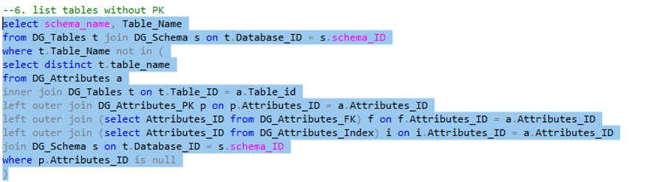

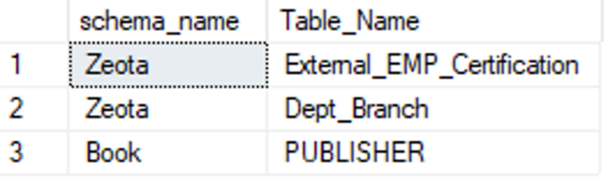

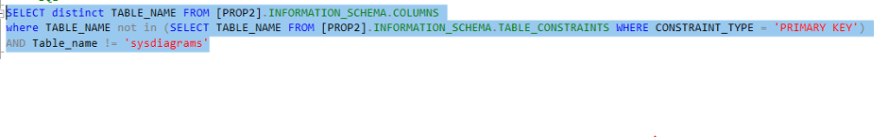

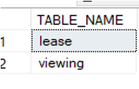

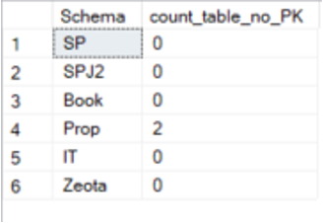

### b. Procedure

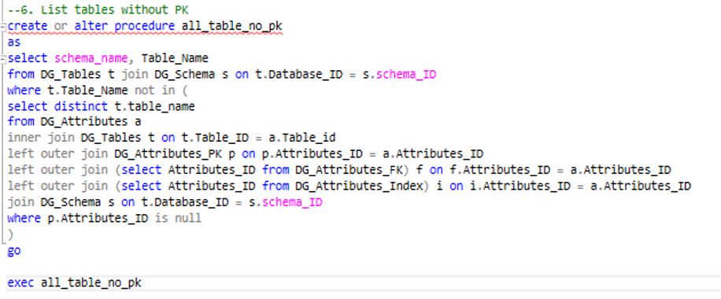

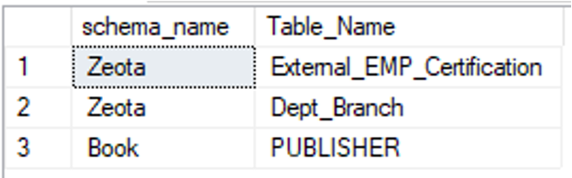

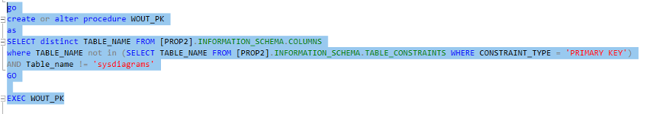

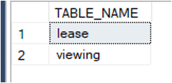

### c. UDF

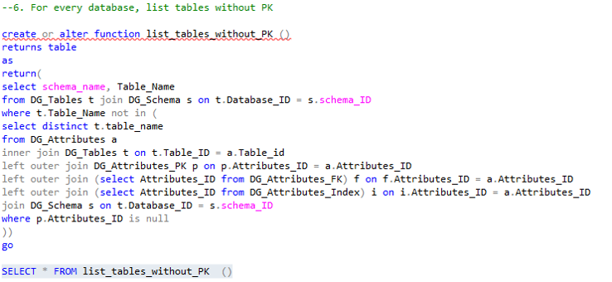

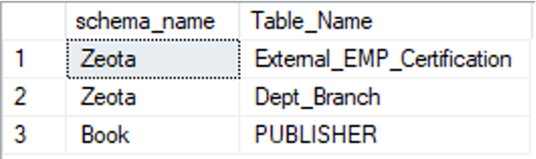

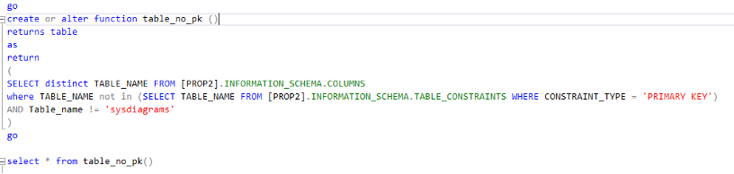

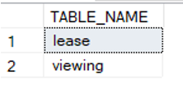

### e. Pivot

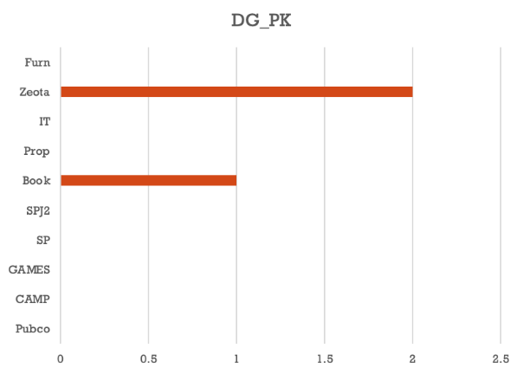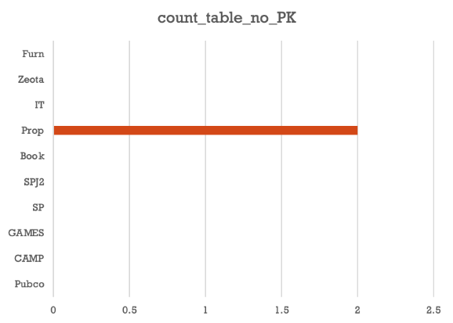

### f. SSRS

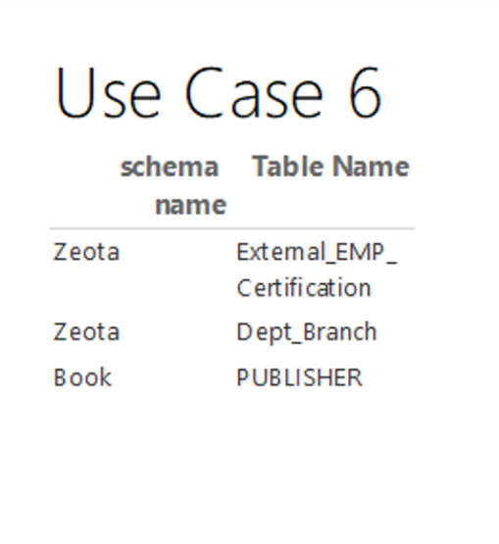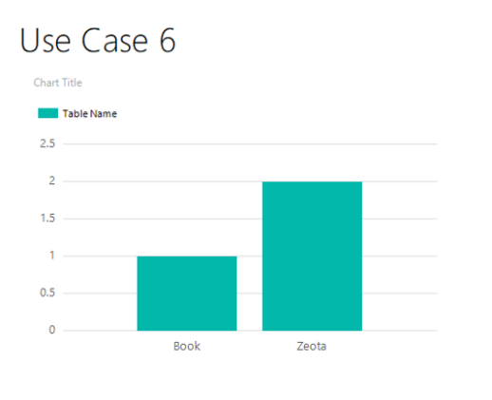

### g. Power BI

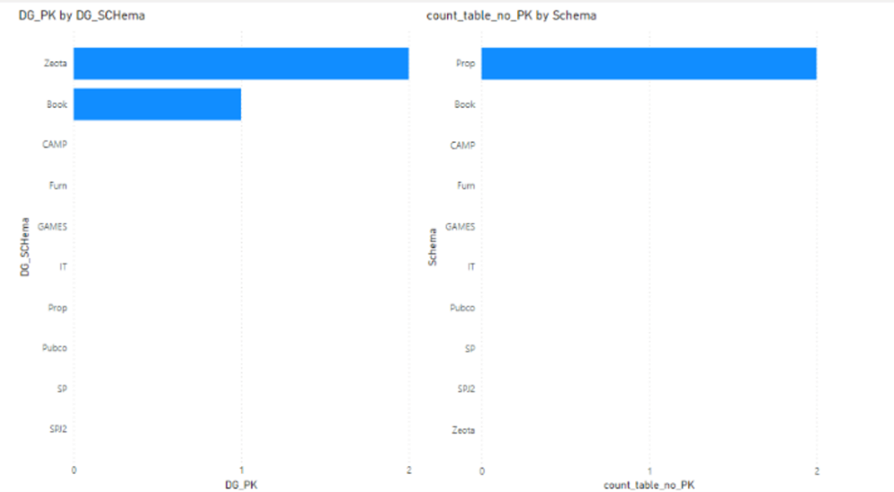

### h. Python

## 

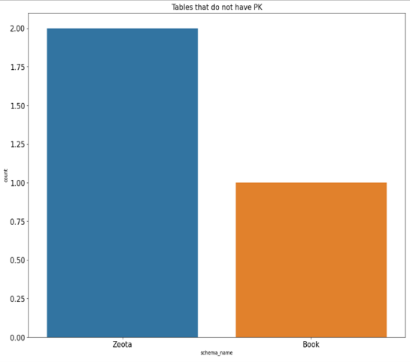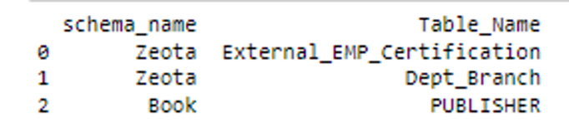

# 7. For every database, list tables without IDX

### a. SQL

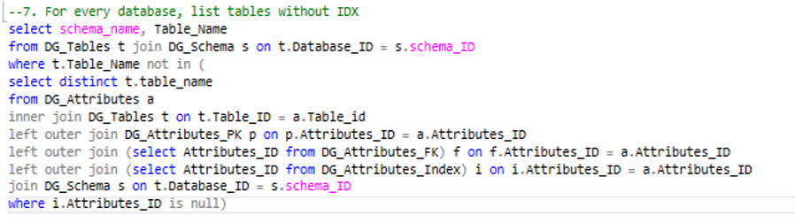

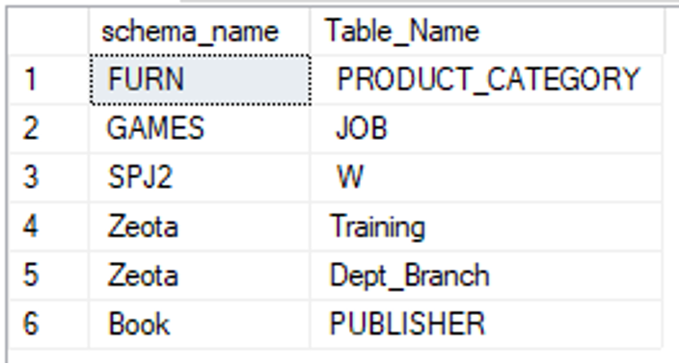

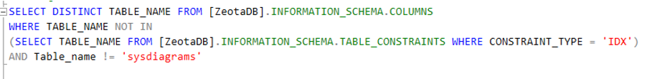

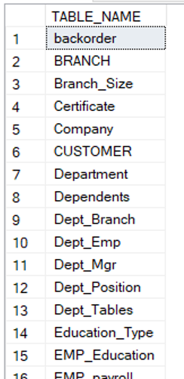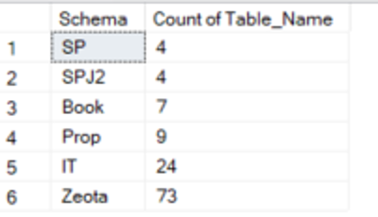

### b. Procedure

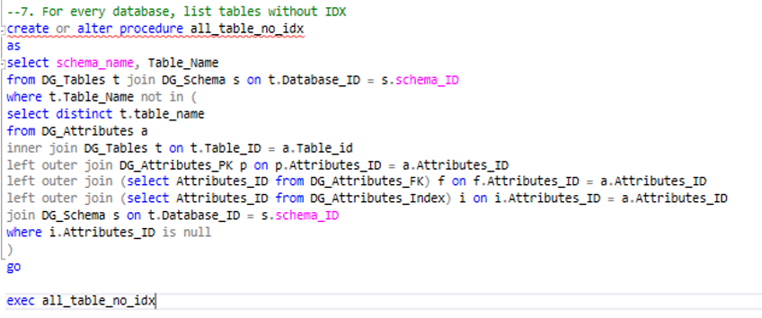

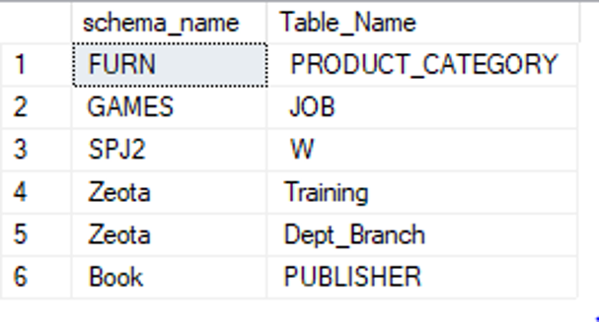

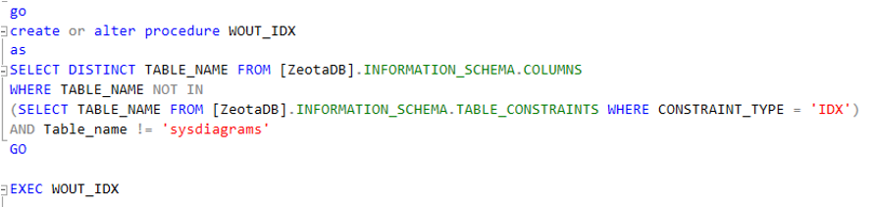

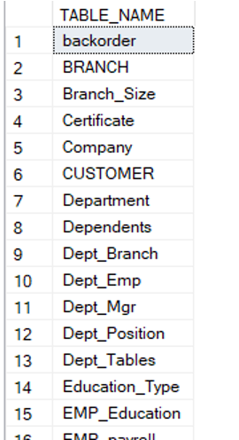

### c. UDF

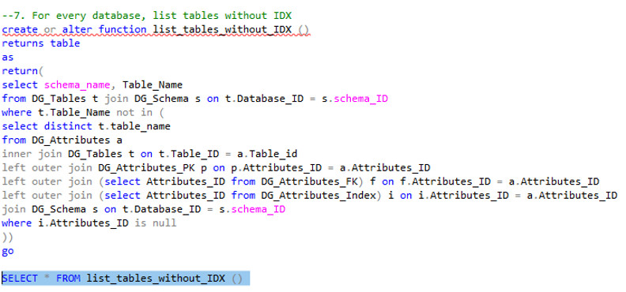

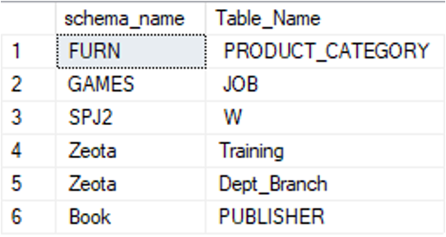

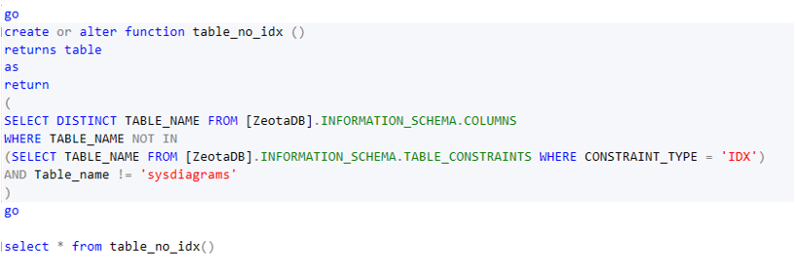

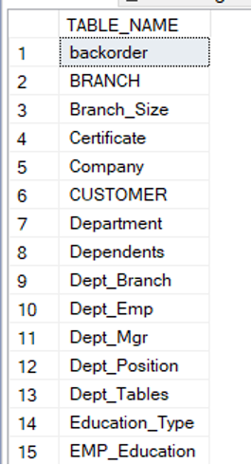

### e. Pivot

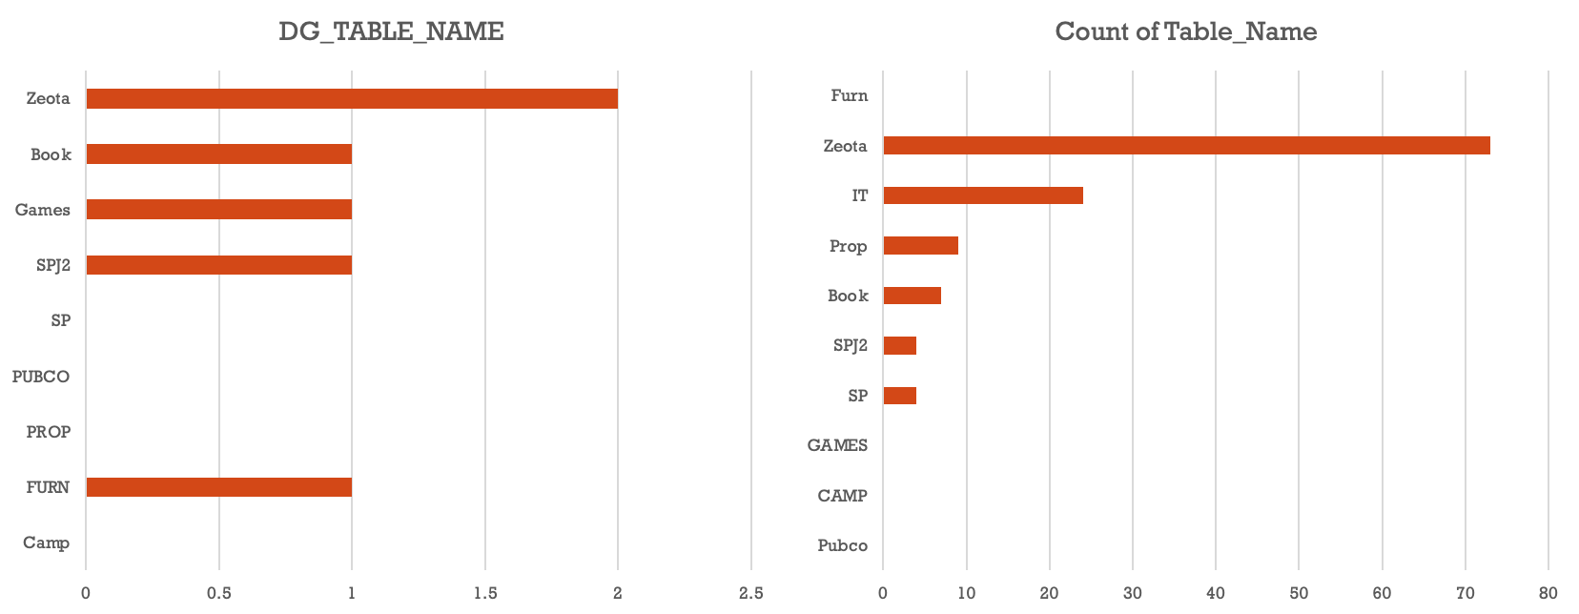

### f. SSRS

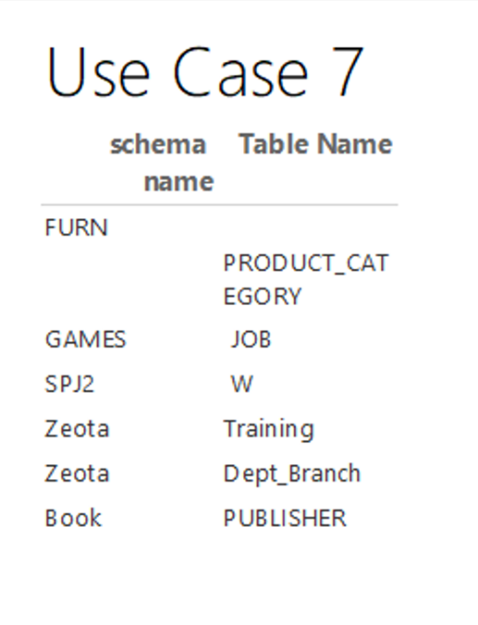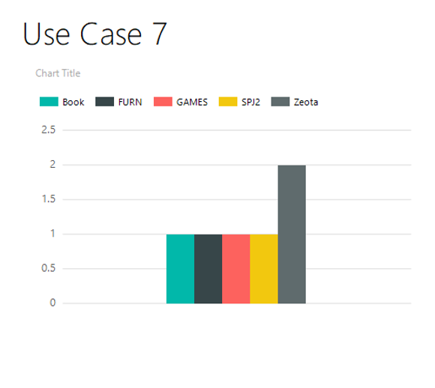

### g. Power BI

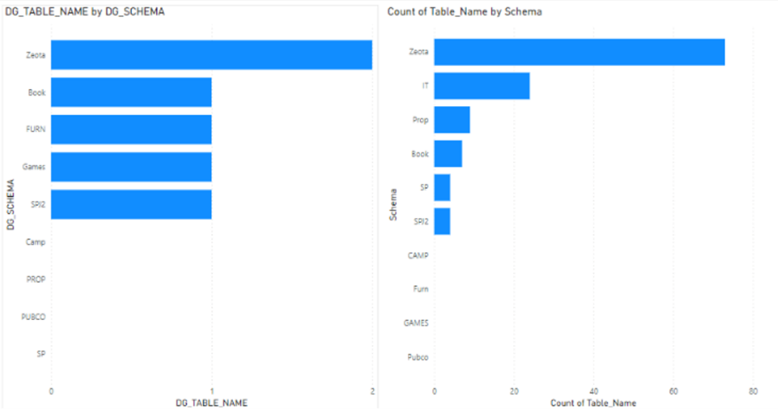

### h. Python

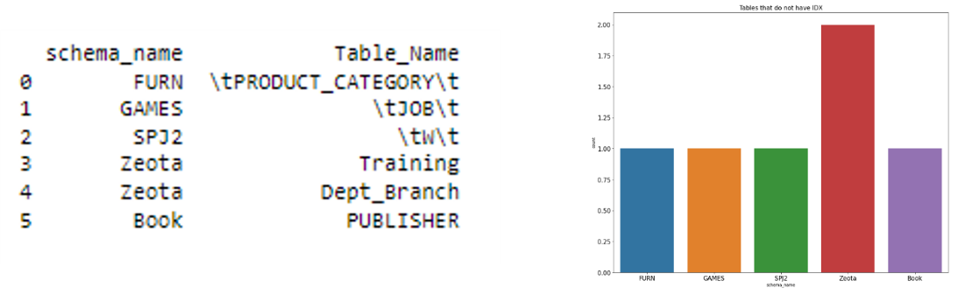

# 8. For every database, list tables with PK but without FK

## 1. For all MSSQL Schemas (Goal is to this in one program)

### a. SQL

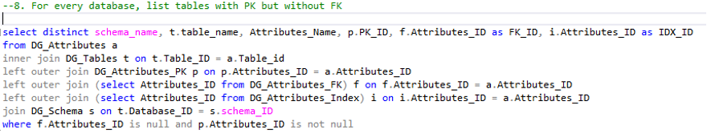

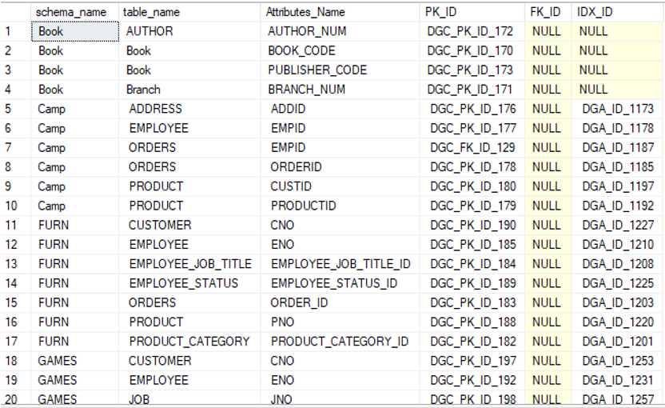

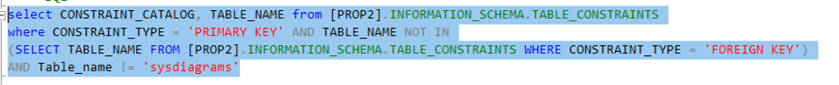

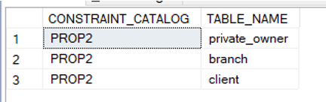

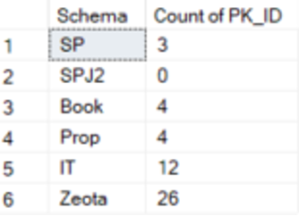

### b. Procedure

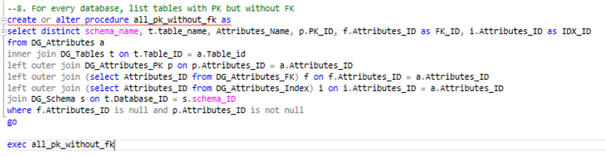

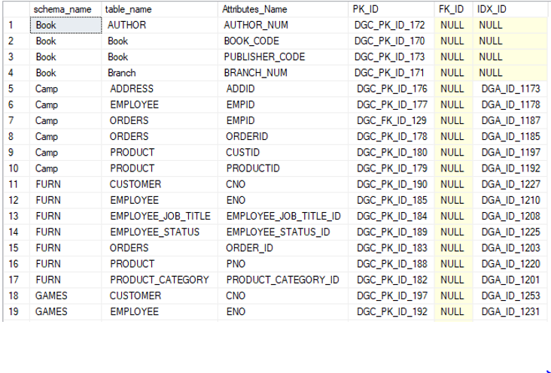

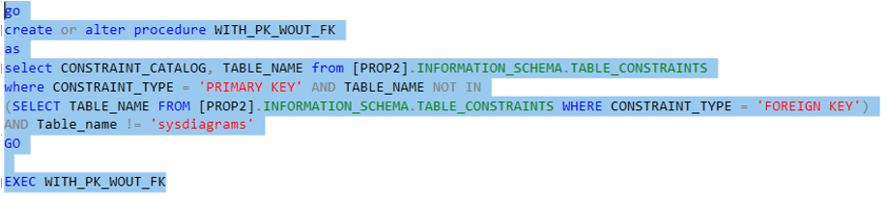

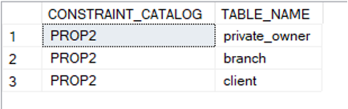

### c. UDF

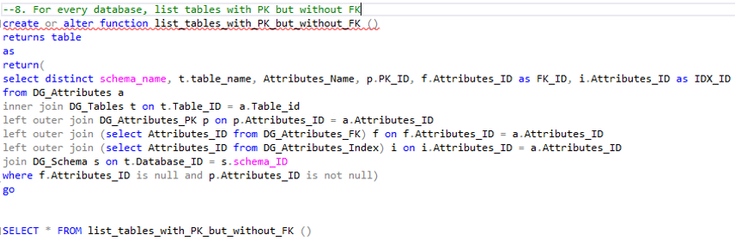

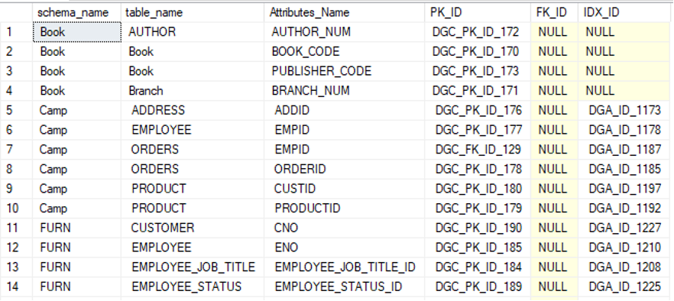

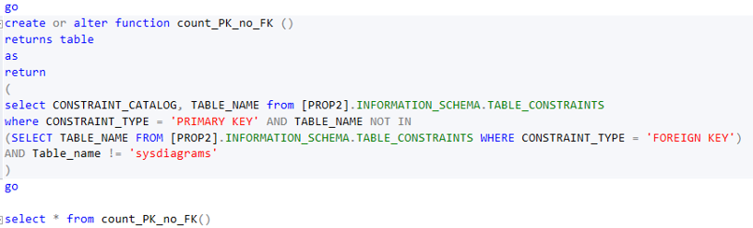

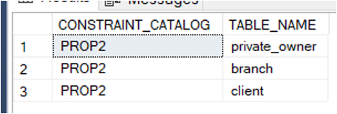

### e. Pivot

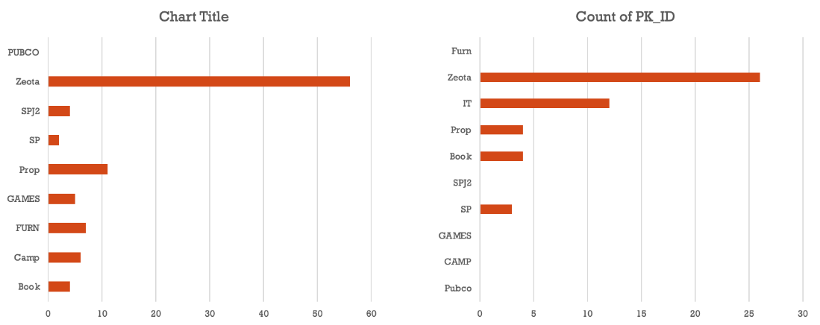

### f. SSRS

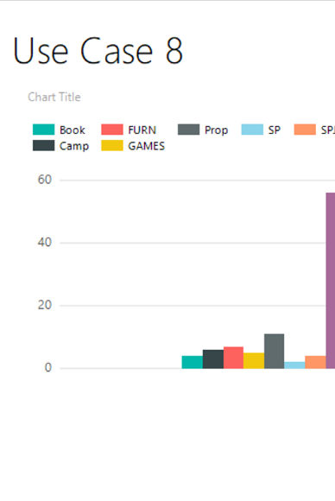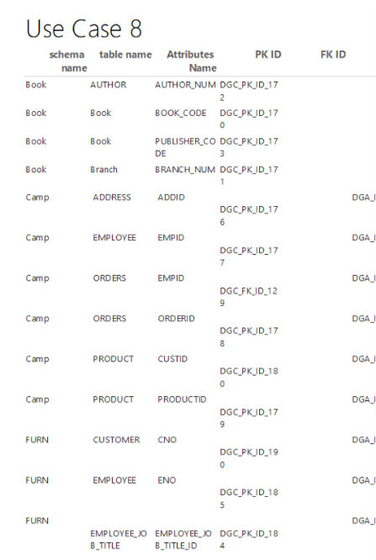

### g. Power BI

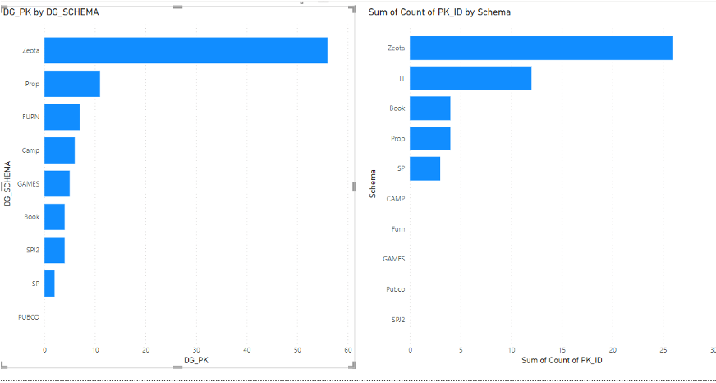

### h. Python

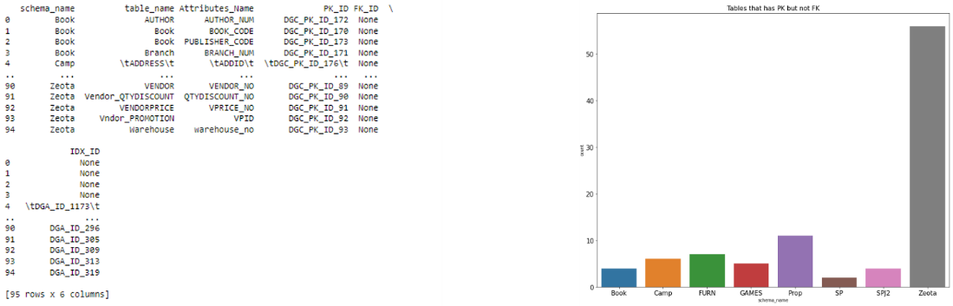

# 9. For every database/schema, list tables with PK but without IDX

### a. SQL

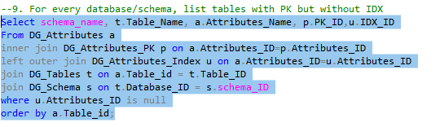

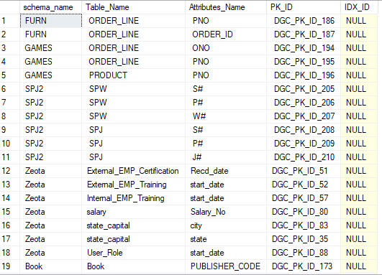

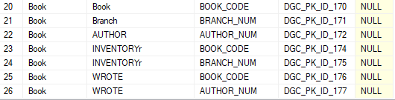

For Indv DB

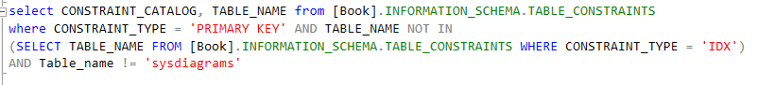

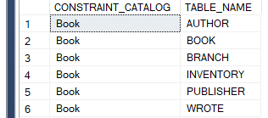

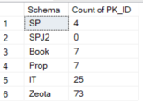

Oracle

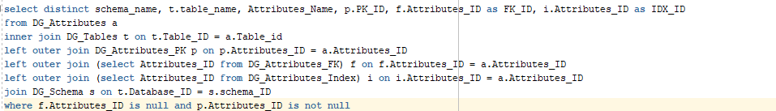

### b. Procedure

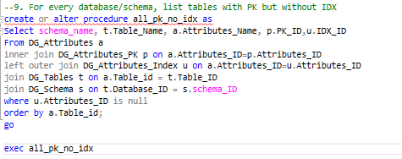

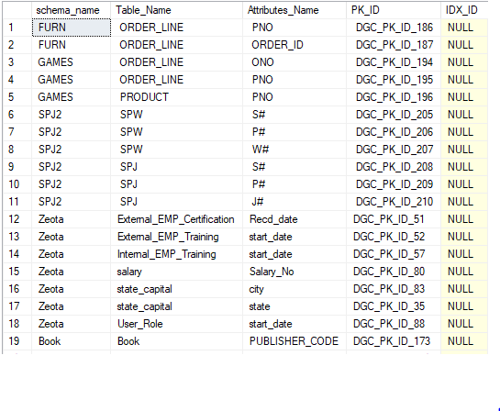

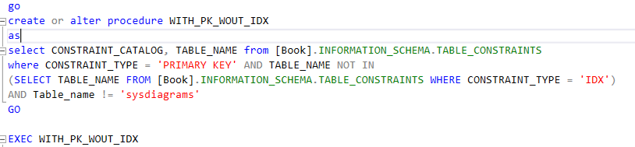

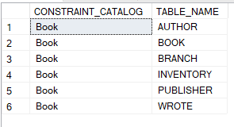

Oracle

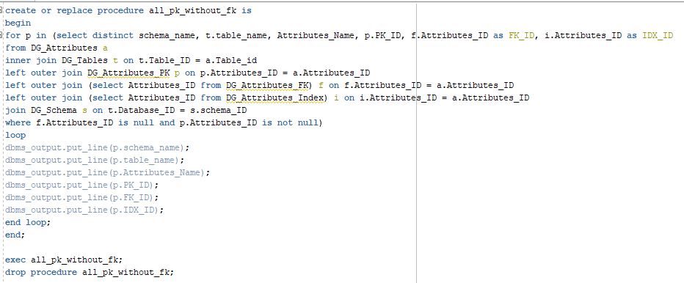

### c. UDF

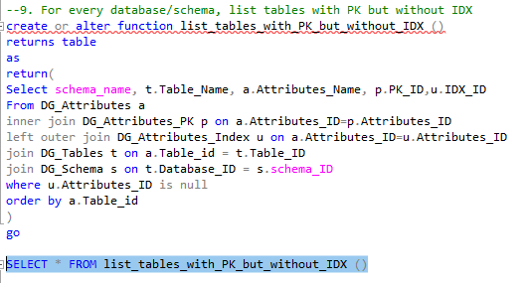

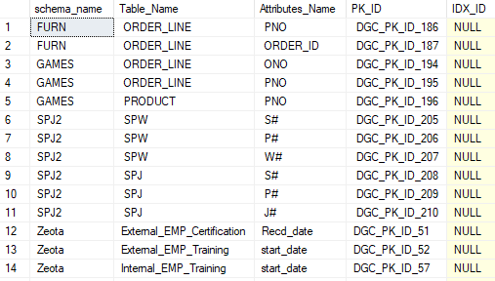

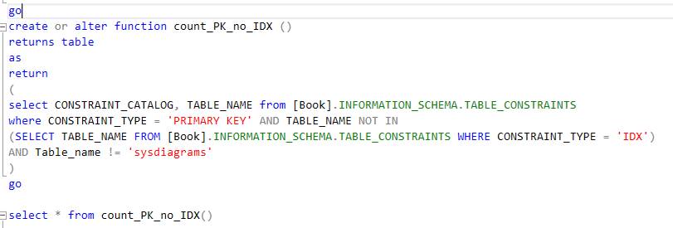

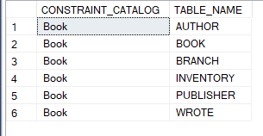

Oracle

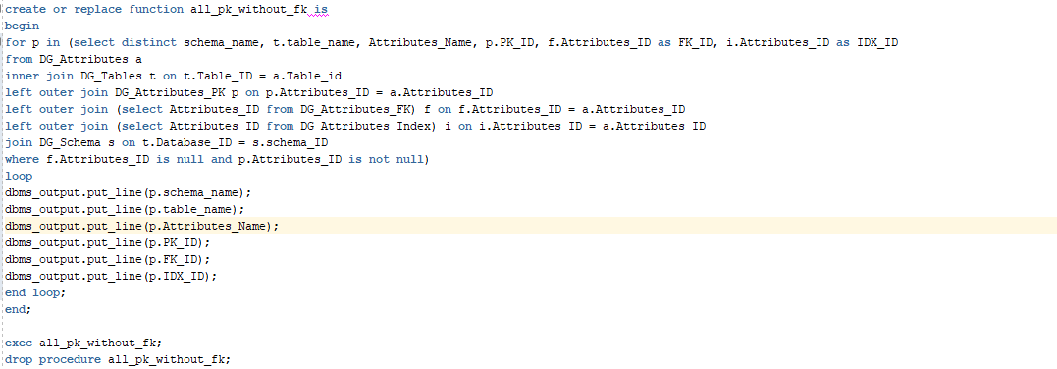

### e. Pivot

### f. SSRS

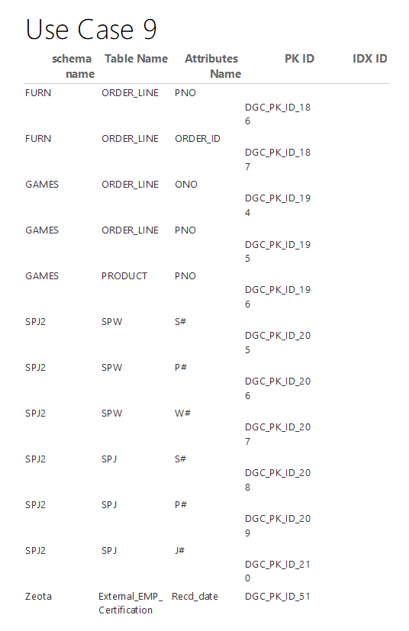

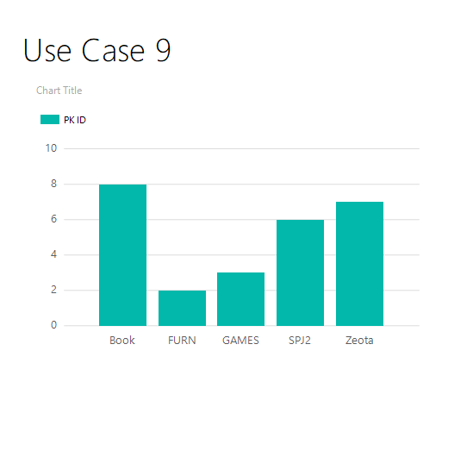

### g. Power BI

### h. Python

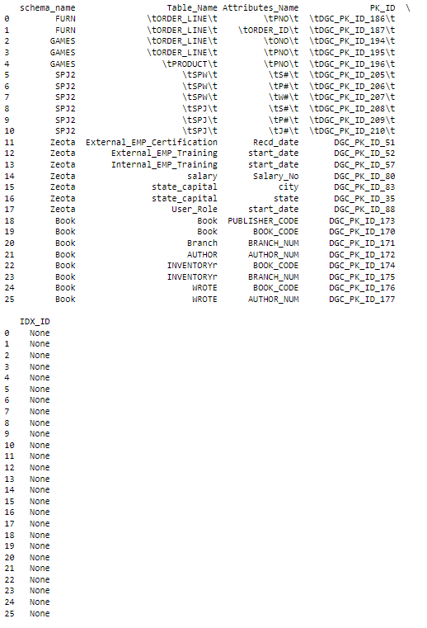

# 10. For every database/schema, list tables with CC

### a. SQL

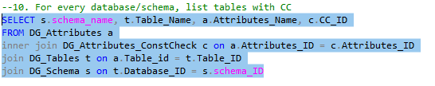

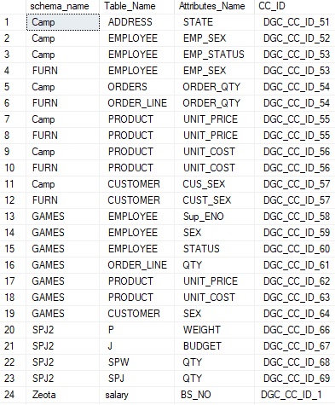



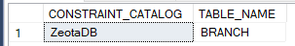

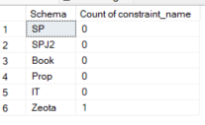

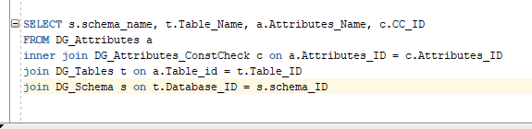

### b. Procedure

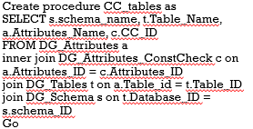

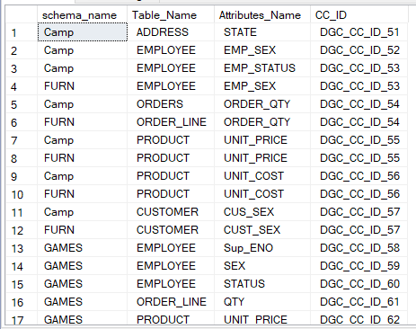

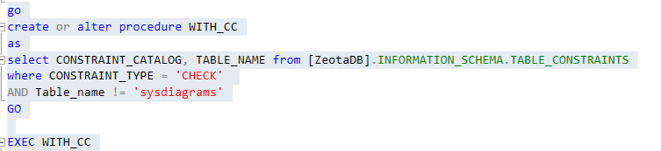

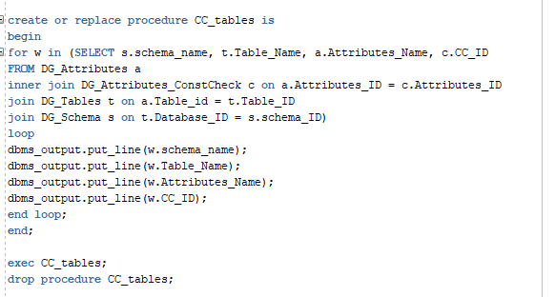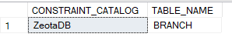

### c. UDF

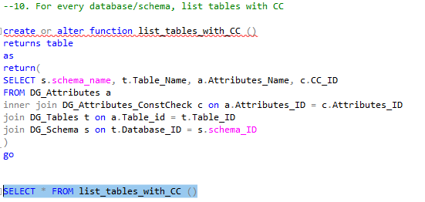

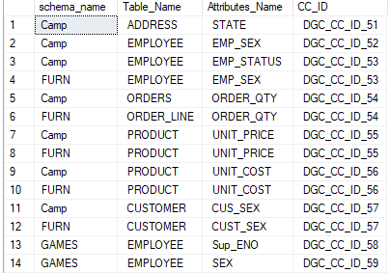

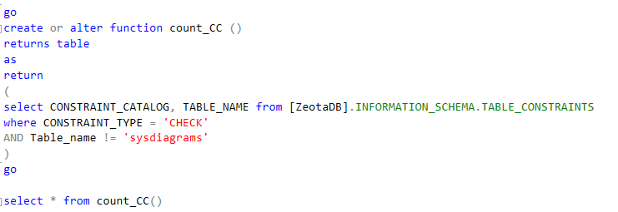

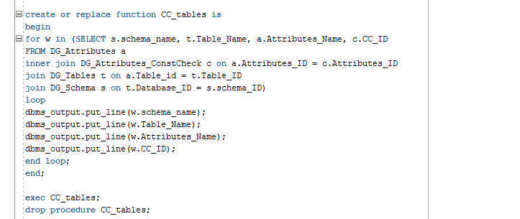

### e. Pivot

### f. SSRS

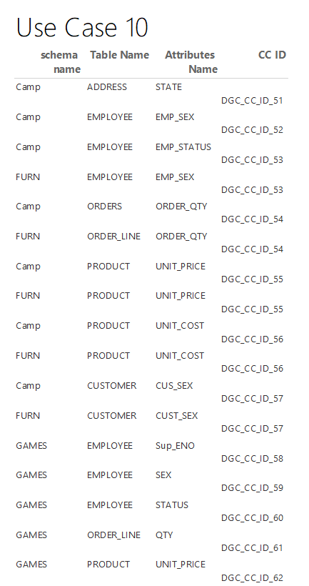

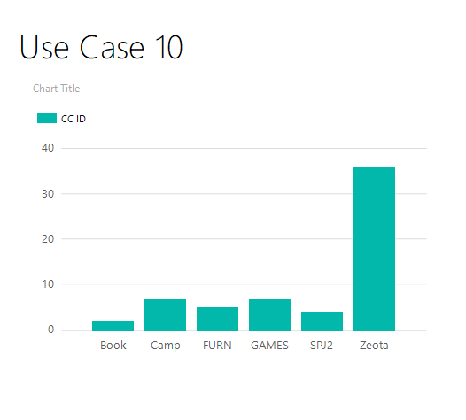

### g. Power BI

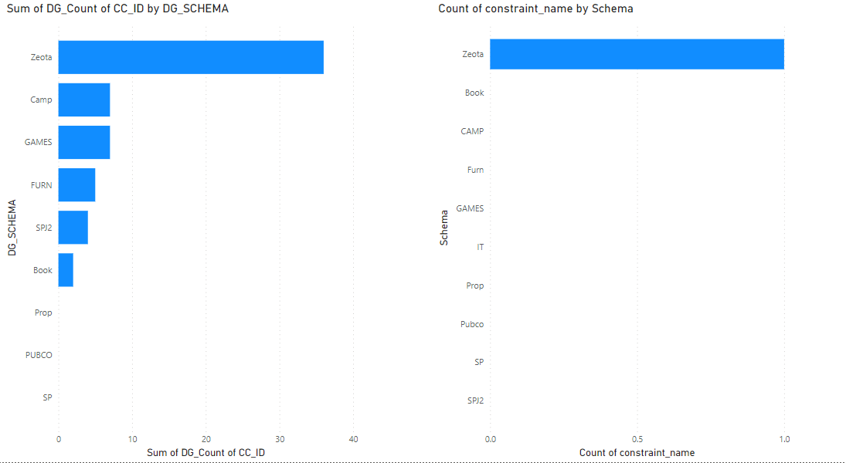

### h. Python

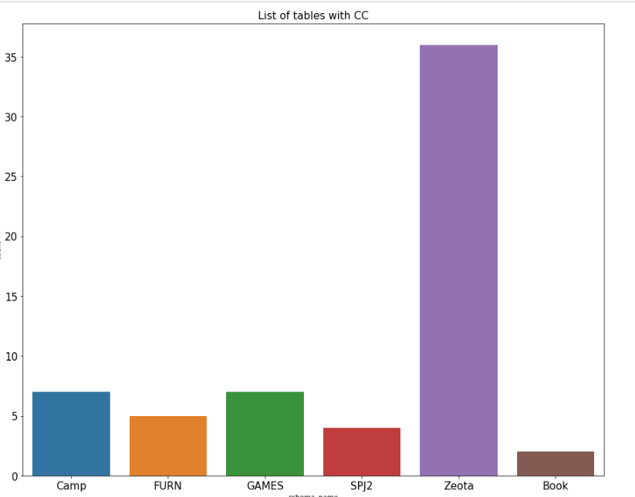

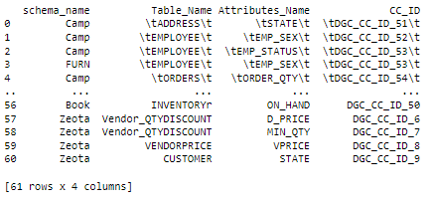

## 

# 11. For every database/schema, list tables with PGM

### a. SQL

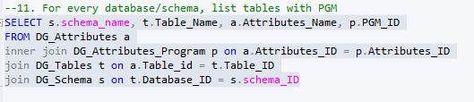

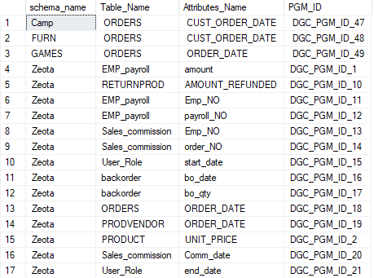

Oracle

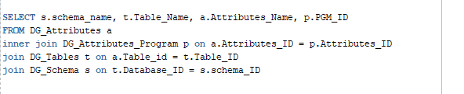

### b. Procedure

Create procedure PGM_tables as  
SELECT s.schema_name, t.Table_Name, a.Attributes_Name, p.PGM_ID  
FROM DG_Attributes a  
inner join DG_Attributes_Program p on a.Attributes_ID = p.Attributes_ID  
join DG_Tables t on a.Table_id = t.Table_ID  
join DG_Schema s on t.Database_ID = s.schema_ID

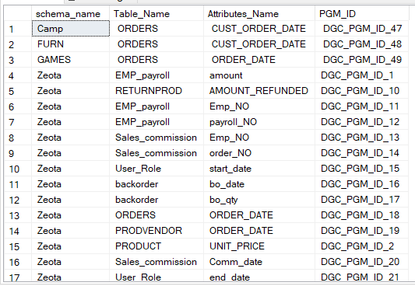

Oracle

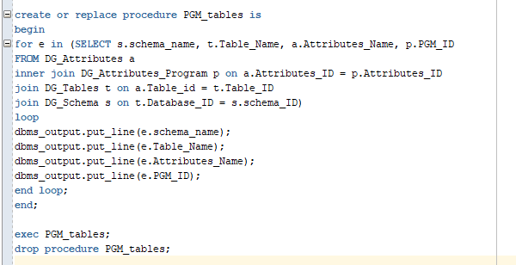

### c. UDF

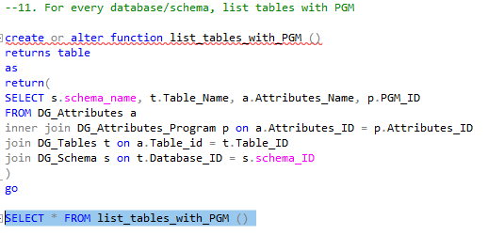

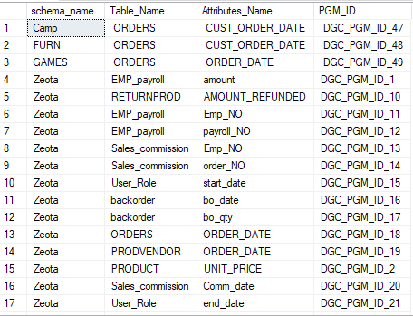

Oracle

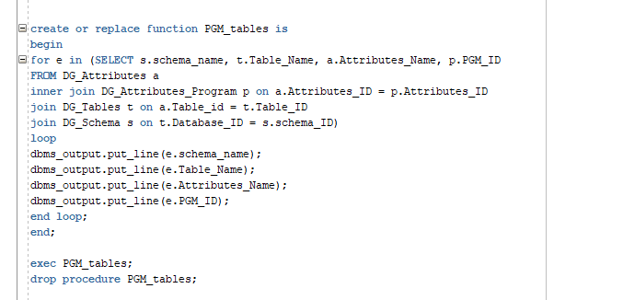

### e. Pivot

### f. SSRS

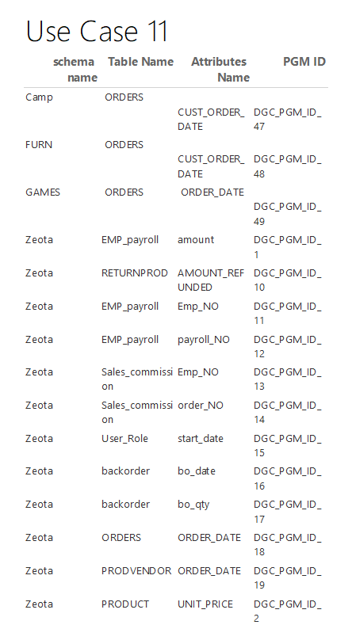

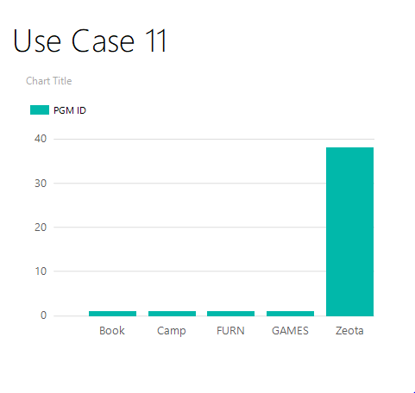

### g. Power BI

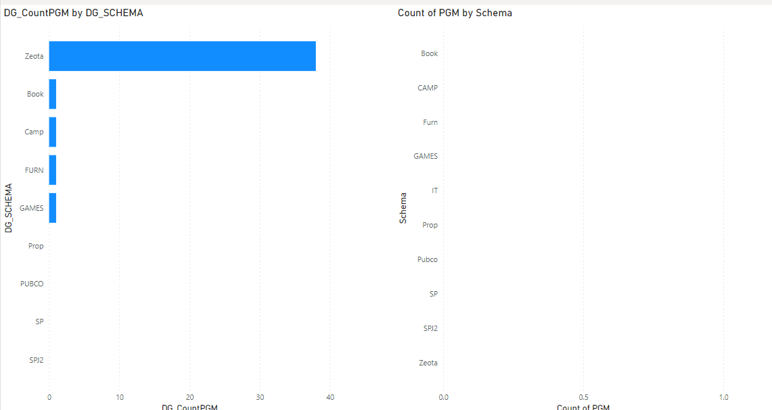

### h. Python

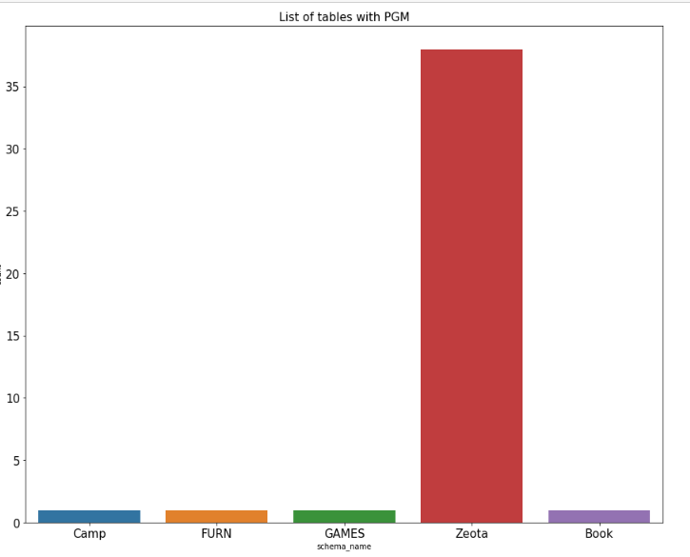

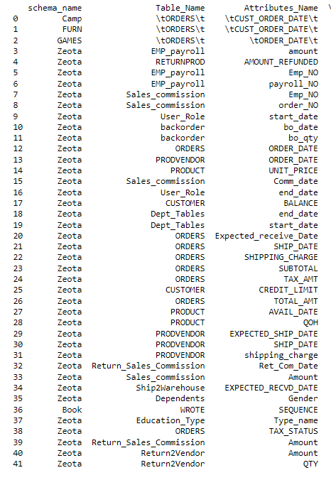

# 12. For every database/schema, list all views (View name, View description)

### a. SQL

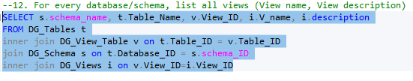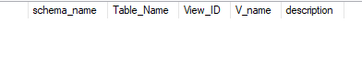

Oracle

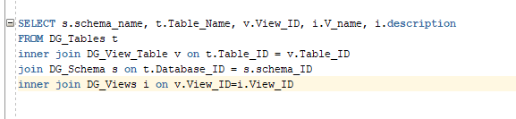

### b. Procedure

Create procedure View_tables as  
SELECT s.schema_name, t.Table_Name, v.View_ID, i.V_name, i.description  
FROM DG_Tables t  
inner join DG_View_Table v on t.Table_ID = v.Table_ID  
join DG_Schema s on t.Database_ID = s.schema_ID  
inner join DG_Views i on v.View_ID=i.View_ID

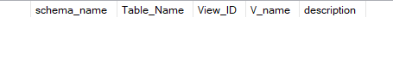

Oracle

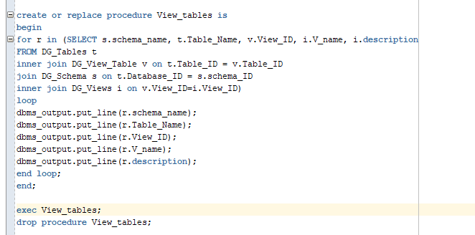

### c. UDF

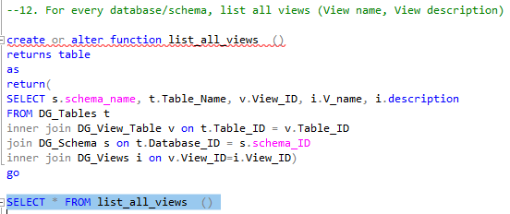



Oracle

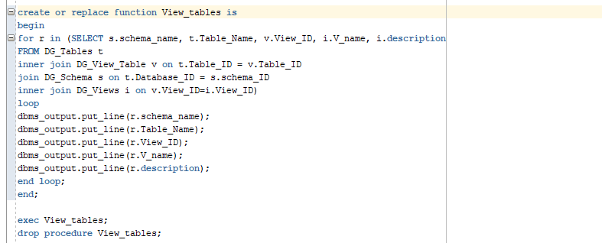

### e. Pivot

### f. SSRS

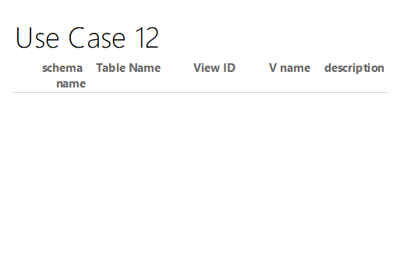

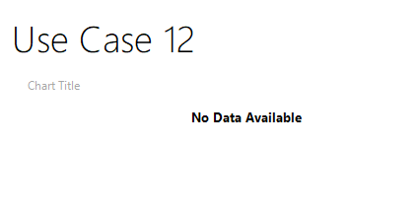

### g. Power BI

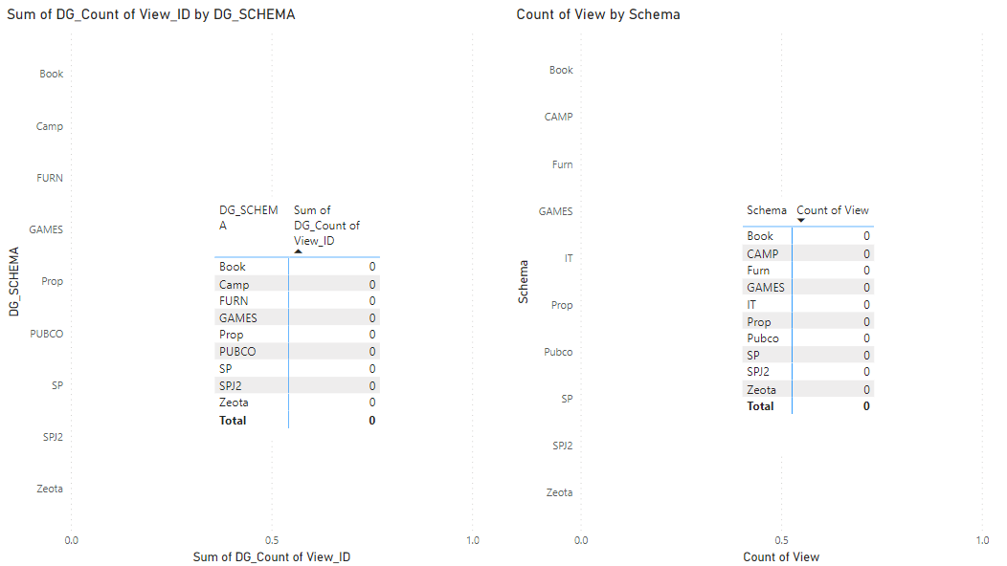

### h. Python

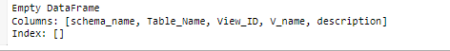

# 13. For every database/schema, list all table with audit table

### SQL

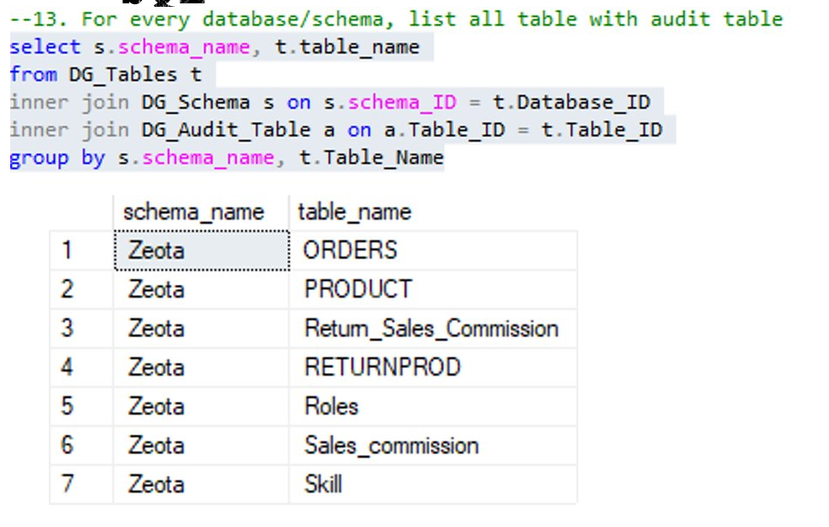

### Procedure

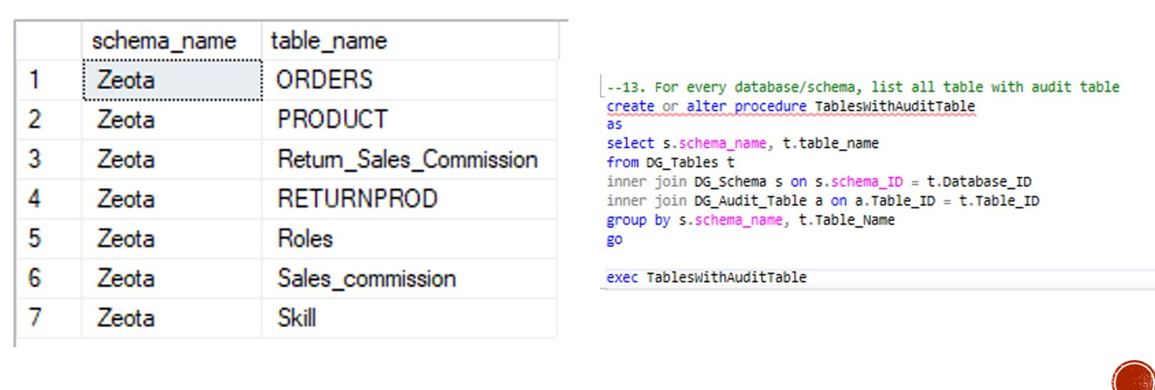

### UDF

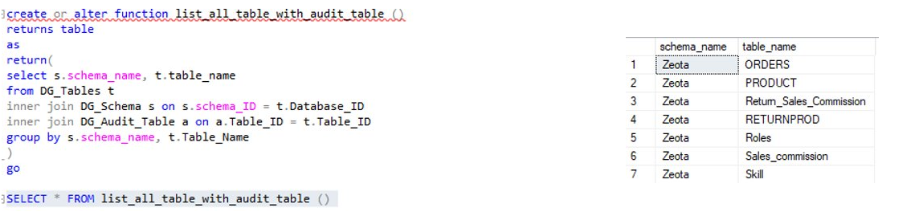

### Pivot

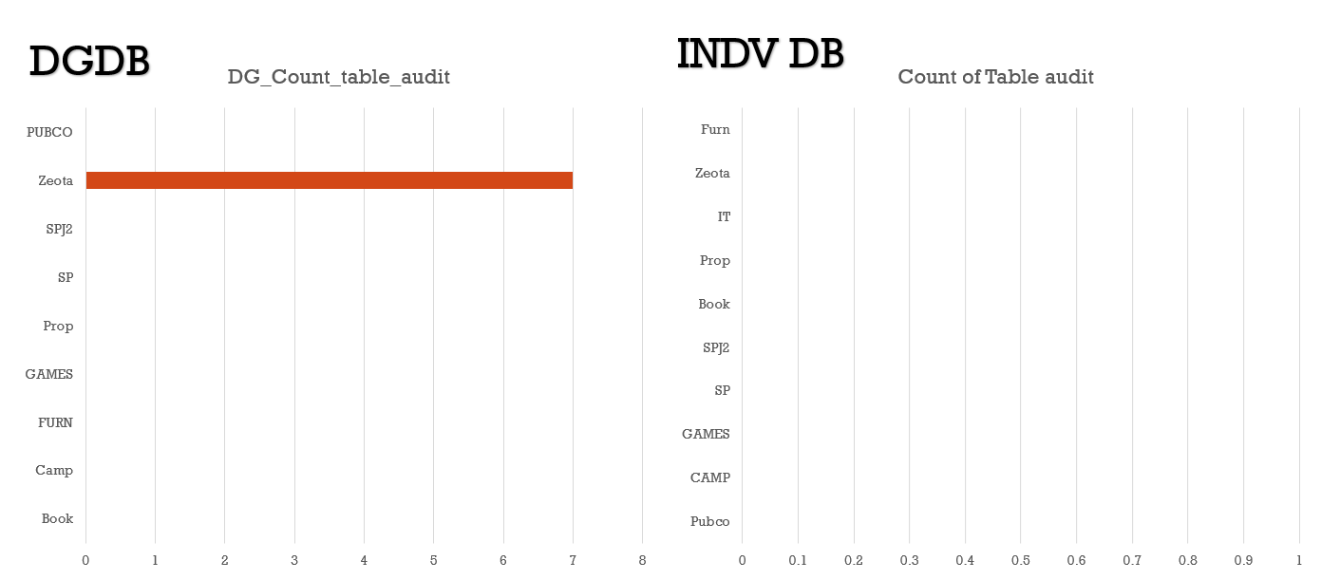

### SSRS

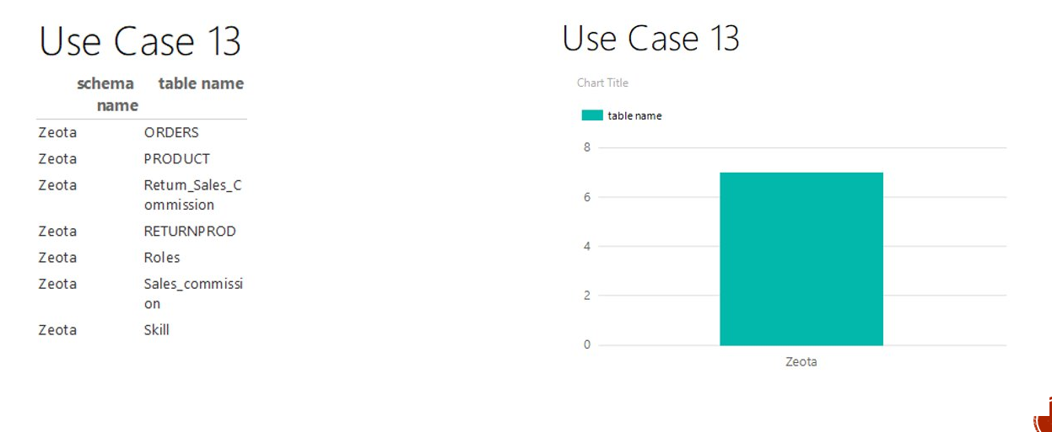

### Power BI

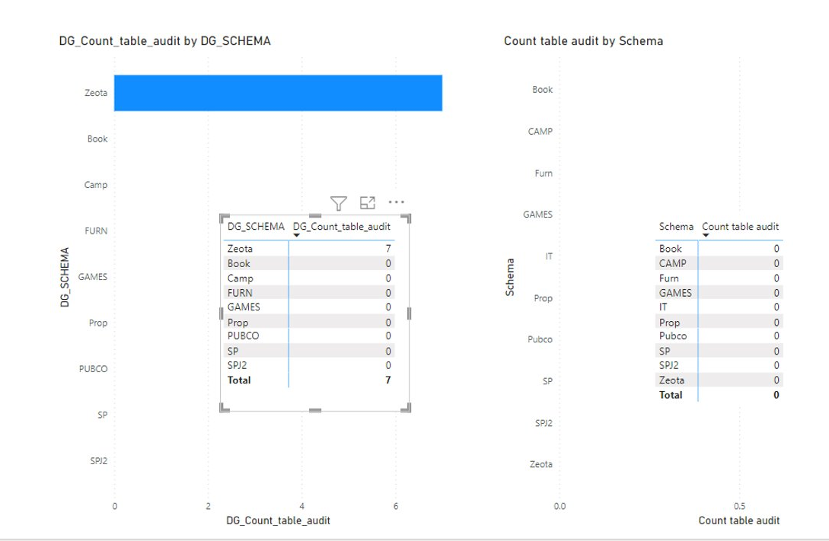

### Python

## 

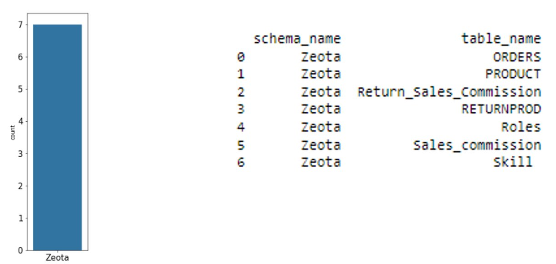

# 14. For every database/schema, list schema, users, role, Dept

### a. SQL

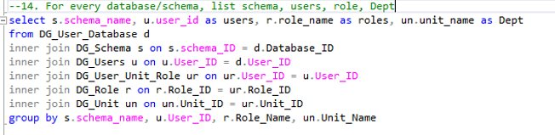 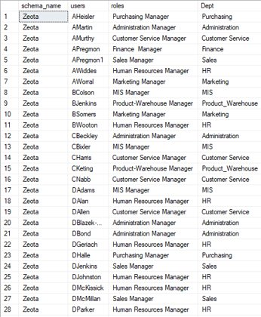

### b. Procedure

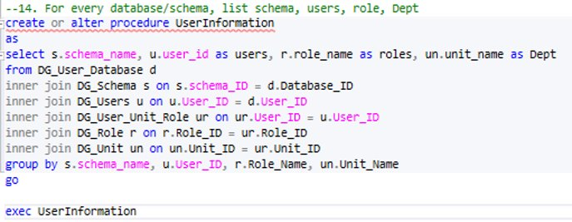

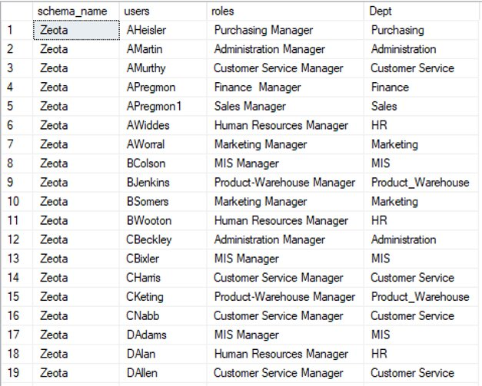

### e. Pivot

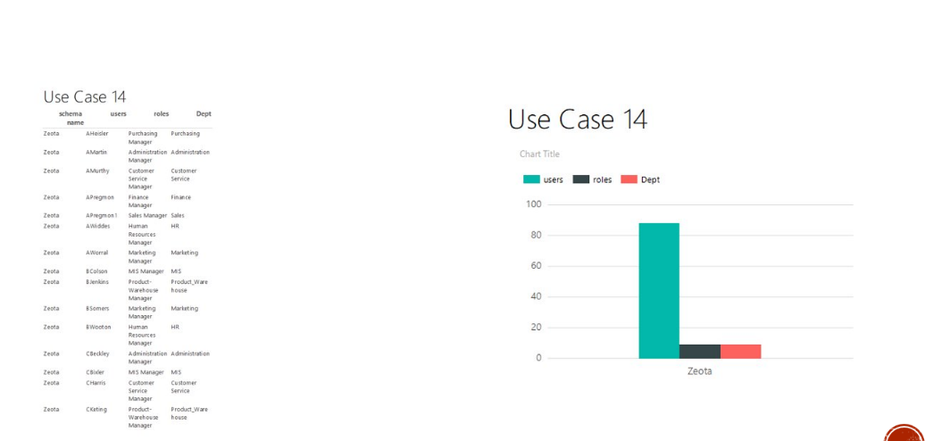

### f. SSRS

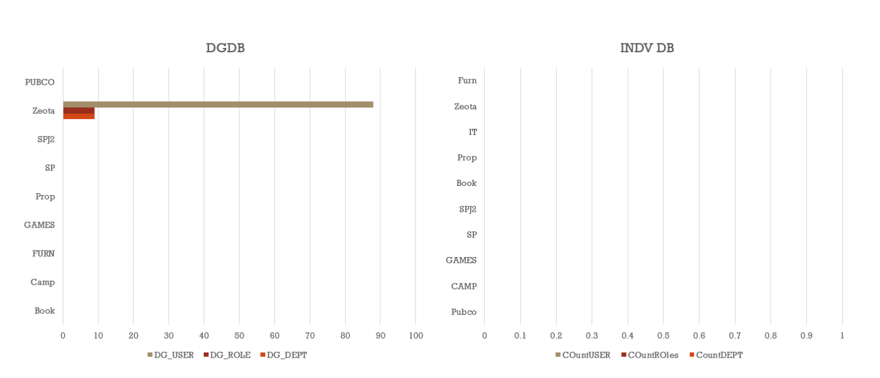

### g. Power BI

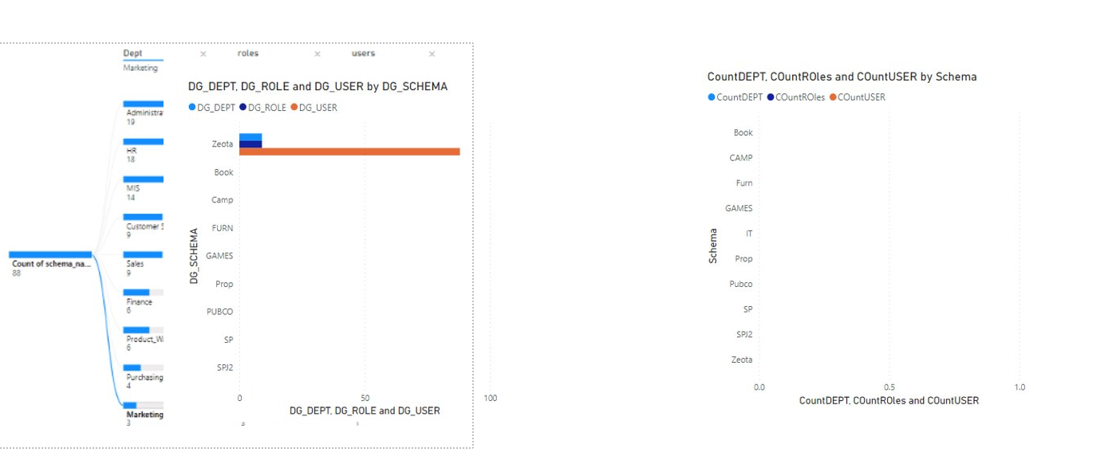

### h. Python

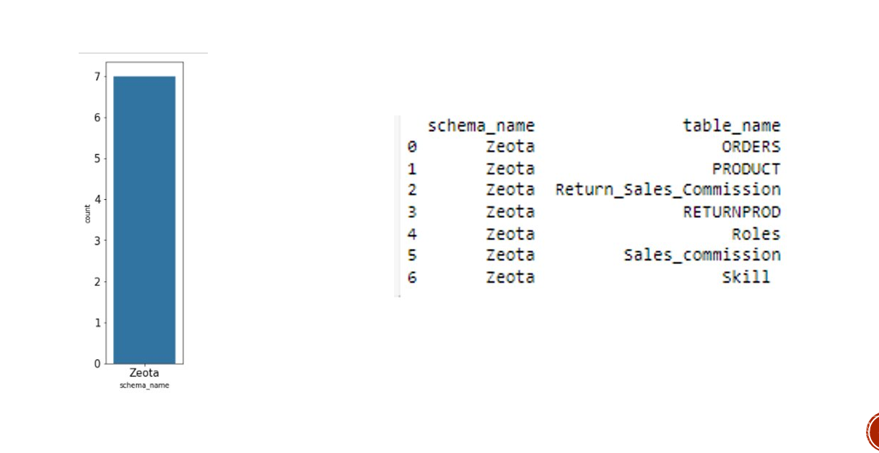

# 15. For every database/schema, list schema equipped with triggers to manage change in users

### a. SQL

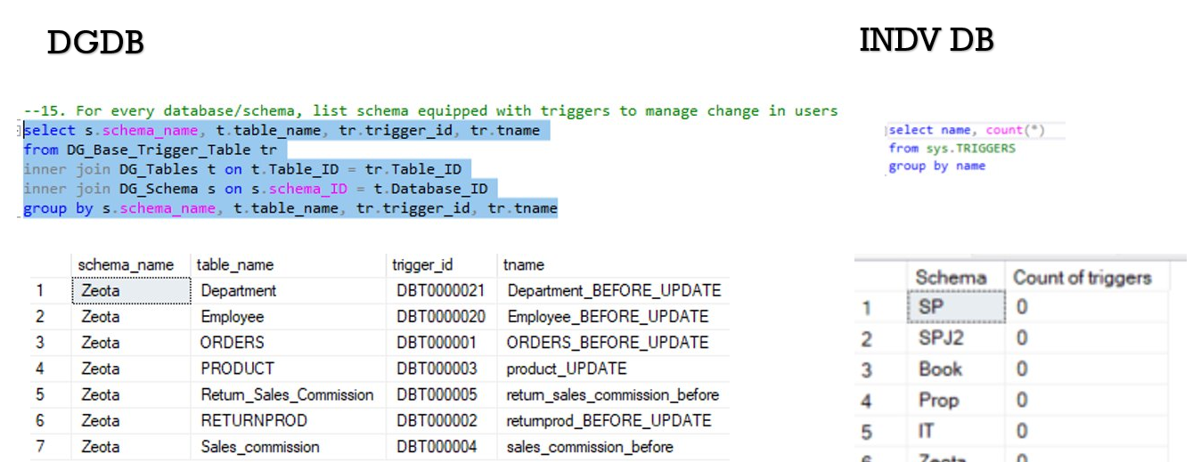

### b. Procedure

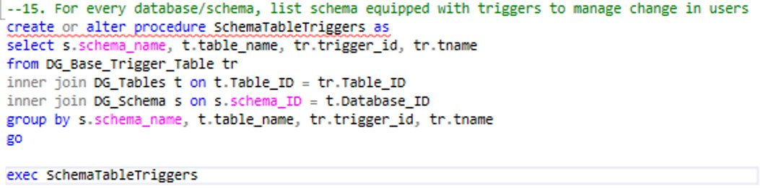

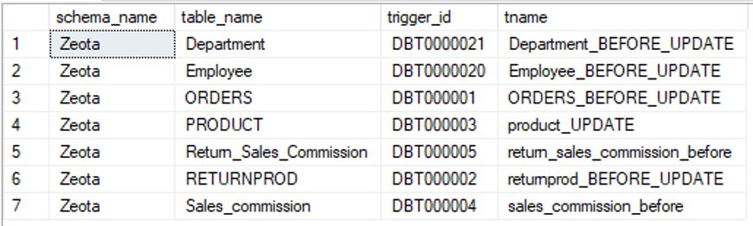

### UDF

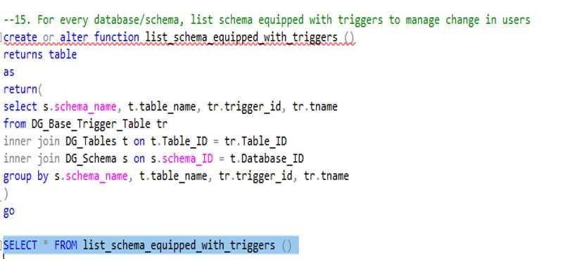

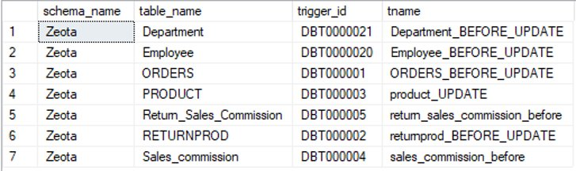

### Pivot

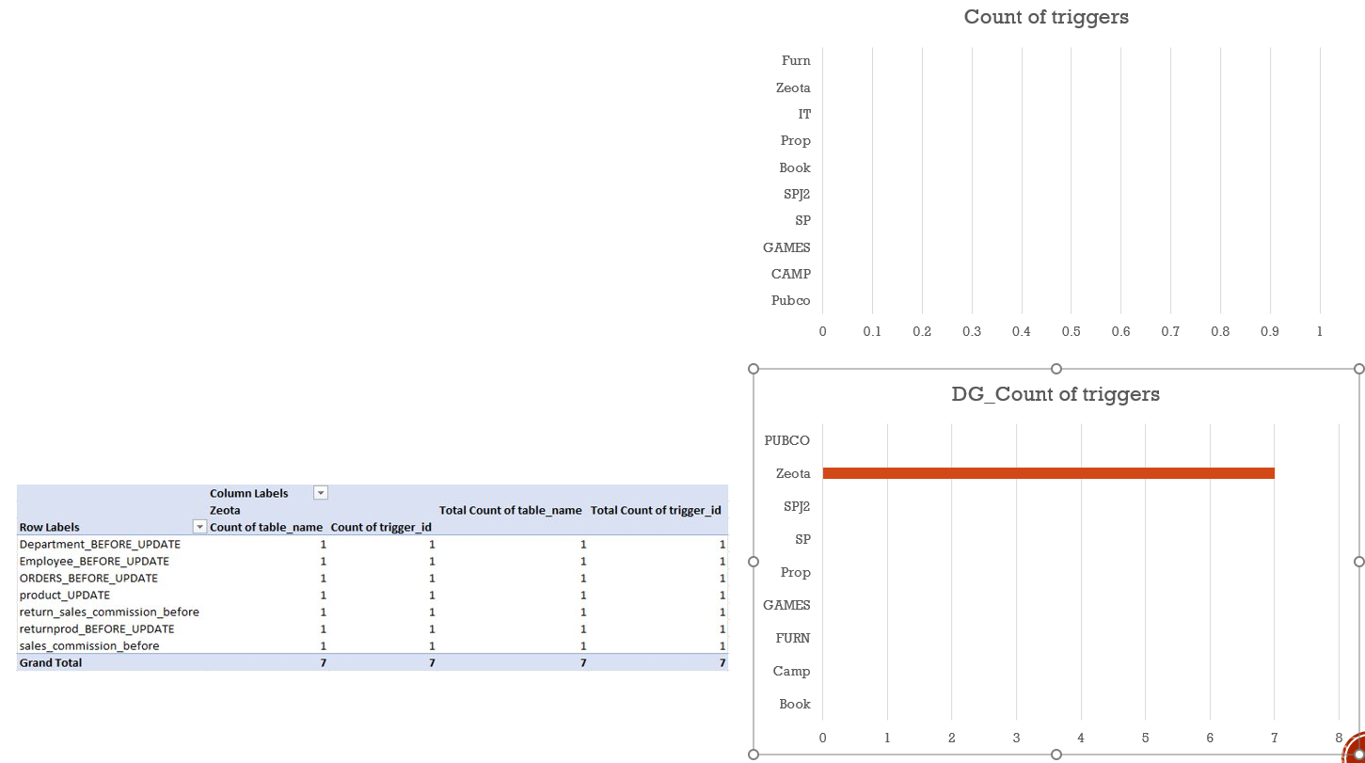

### SSRS

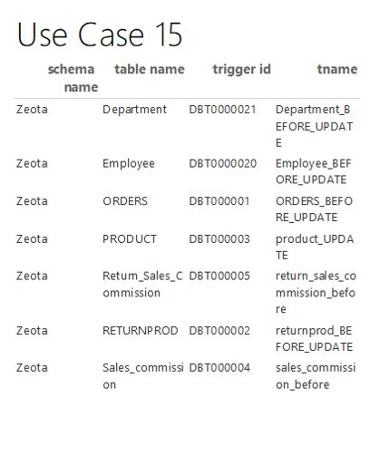 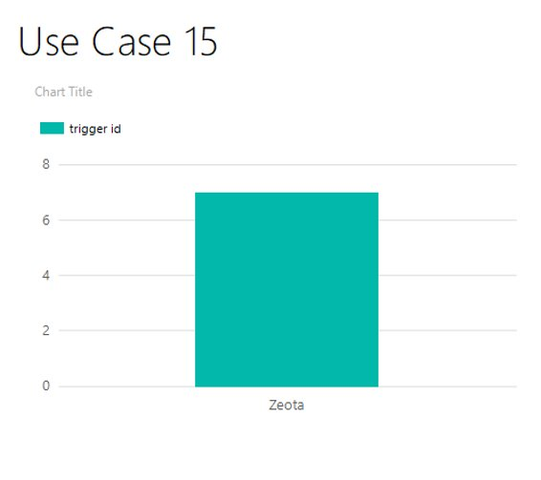

### Power BI

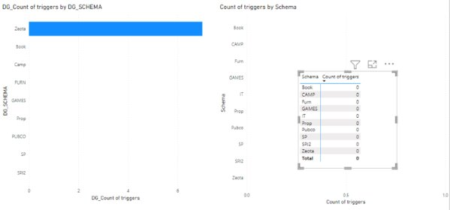

### Python

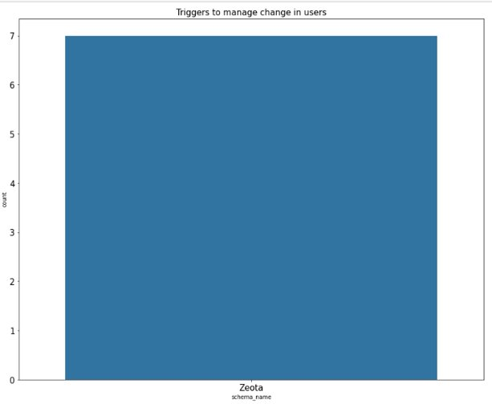 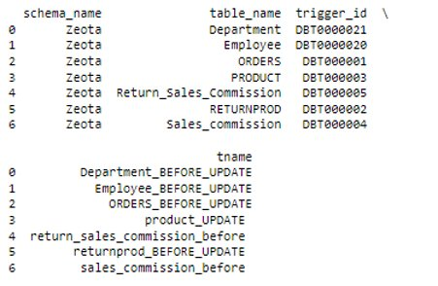

# 16. For every database/schema, list schema, dept, role, tables a. SQL

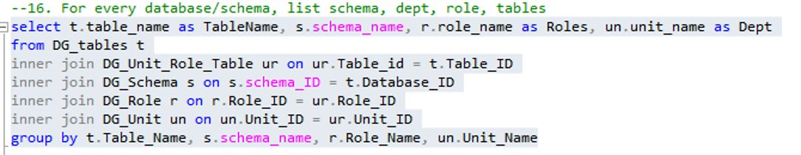

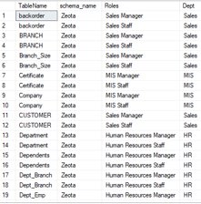

### b. Procedure

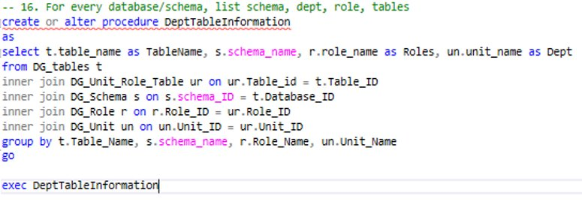

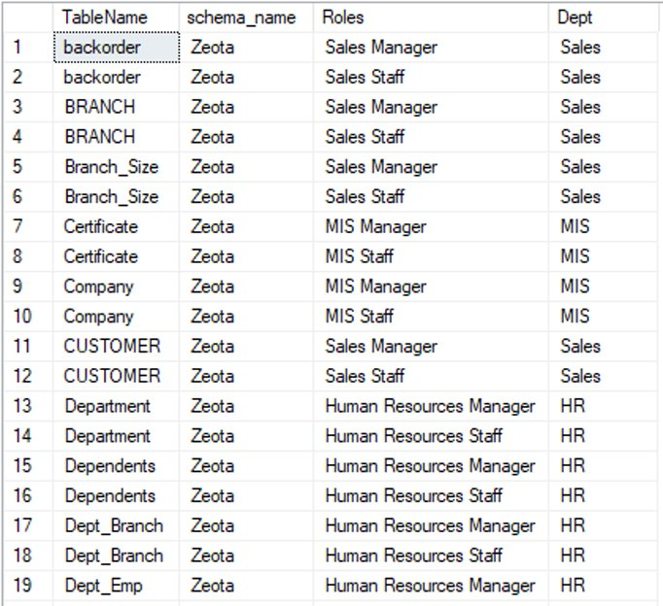

### c. UDF

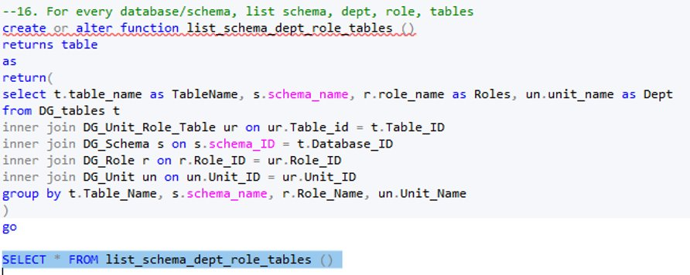

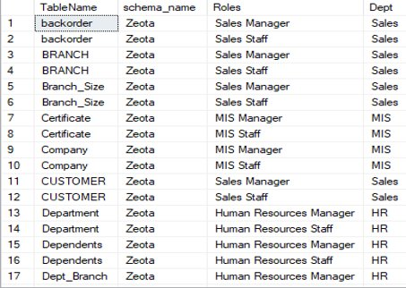

### e. Pivot

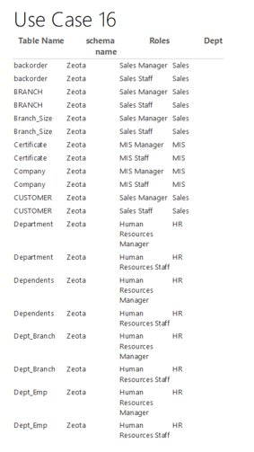  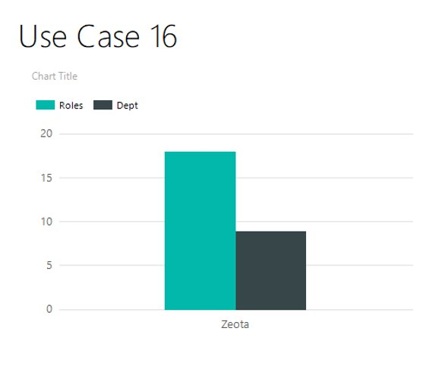

### f. SSRS

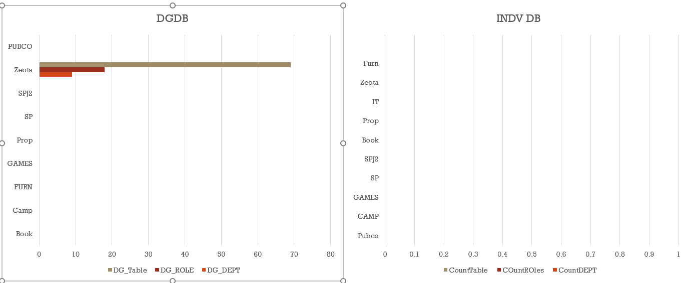

### g. Power BI

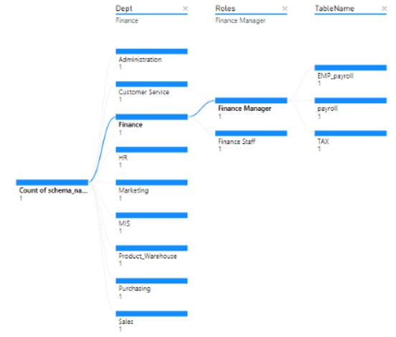  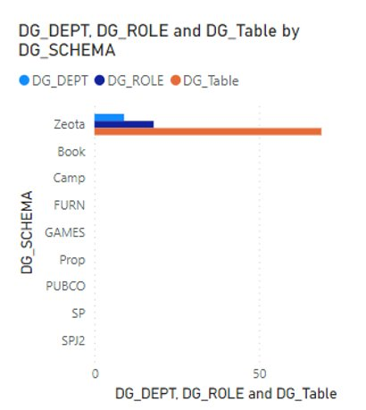

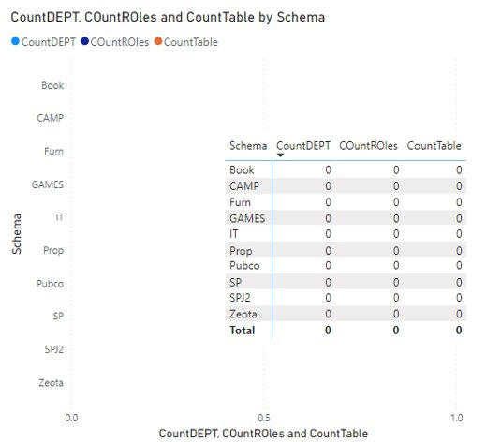

### h. Python

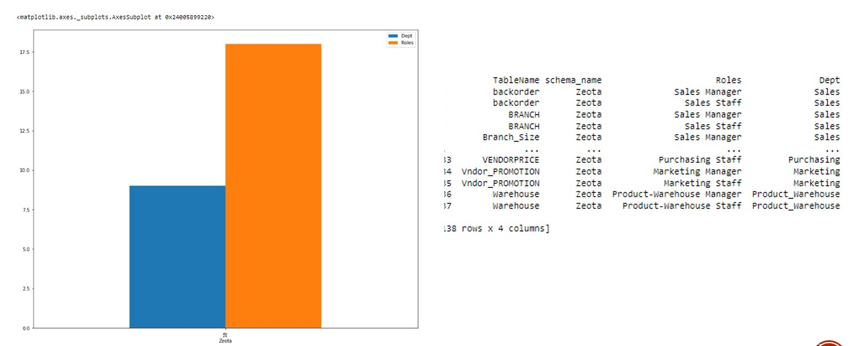

# 17. For every database/schema, list schemas equipped with triggers to manage change in dept/tables

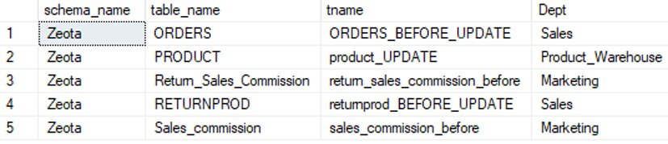

**PROCEDURE​:**

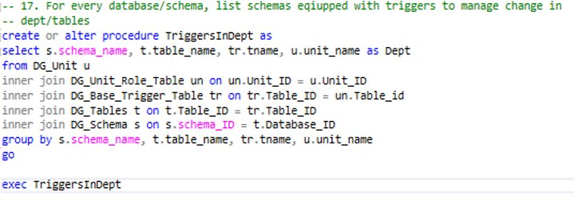

**UDF:**

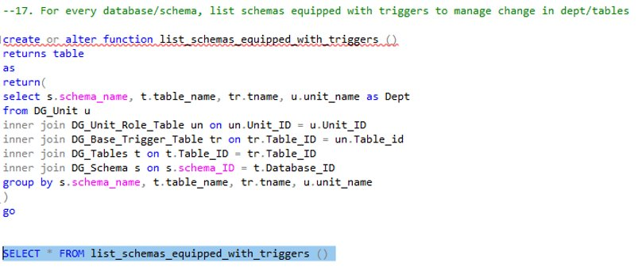

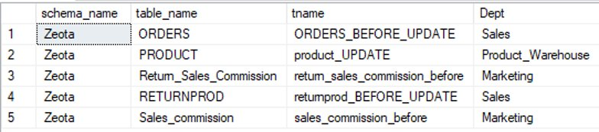

**SSRS**​

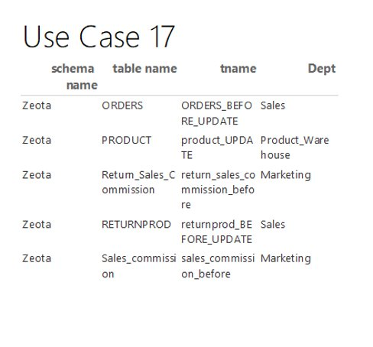  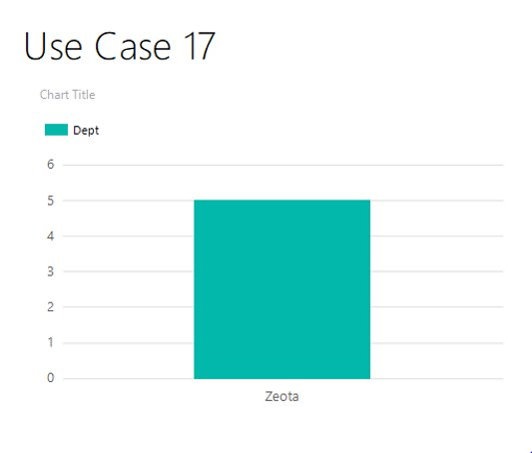

**​**



## PowerBi

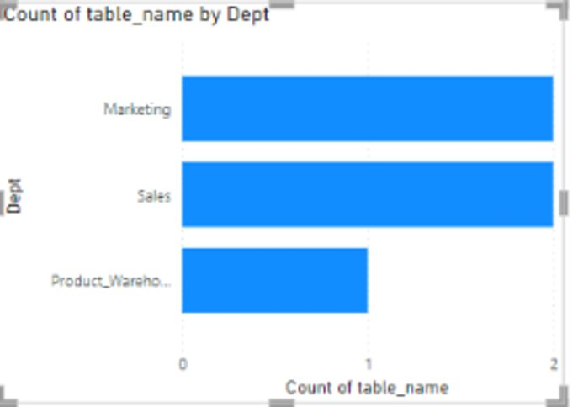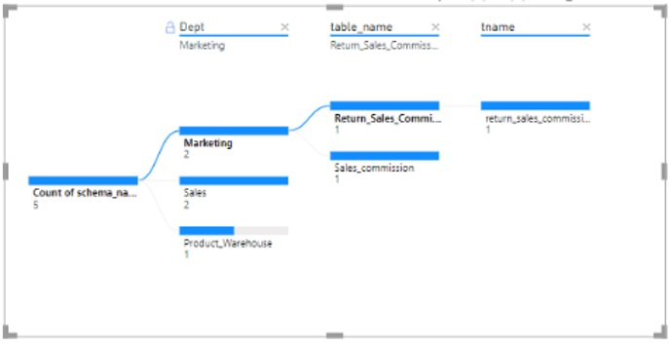

## PYTHON​

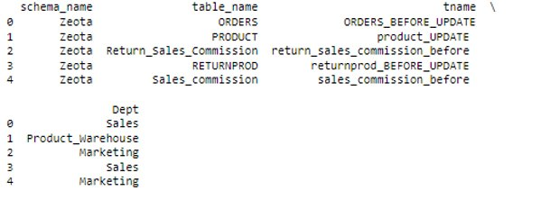

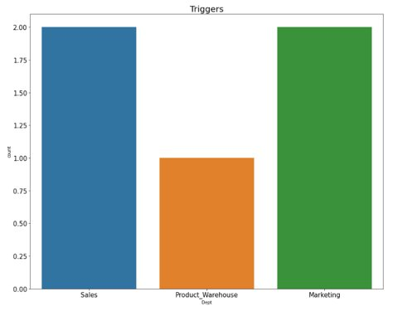  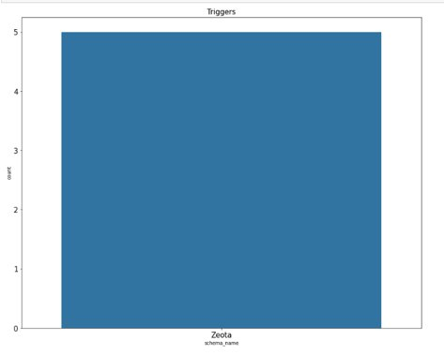

# Appendix

## Member resume

|  |  |  |  |  |  |
| --- | --- | --- | --- | --- | --- |
| **Sprint Evaluation** | **Member 1** | **Member 2** | **Member 3** | **Member 4** | **Member 5** |
| **Team members** | Anthony N Ho | Marcho S Handoko | Zalalem Denekew | Hemen Hagos | Hyesu Lee |
| **Members Participating for development of sprint planning (1=Yes, 0=No)** | 1 | 1 | 1 | 1 | 1 |
| **Presentation script (1=Yes, 0=No)** | 1 | 1 | 1 | 1 | 1 |
| **Scrum1 Report: all stories member was supposed to do (Plan vs Actual) 2=full, 1=partial,   0=none** | 2 | 2 | 2 | 2 | 2 |
| **Scrum2 Report: all stories member was supposed to do (Plan vs Actual) 2=full, 1=partial,   0=none** | 2 | 2 | 2 | 2 | 2 |
| **Scrum3 Report: all stories member was supposed to do (Plan vs Actual) 2=full, 1=partial,   0=none** | 2 | 2 | 2 | 2 | 2 |
| **Scrum4 Report: all stories member was supposed to do (Plan vs Actual) 2=full, 1=partial,   0=none** | 2 | 2 | 2 | 2 | 2 |
| **Members participating in Video production (1=Yes, 0=No)** | 1 | 1 | 1 | 1 | 1 |
| **Member Participation in number of Scrums (out of 4 ==> 0,1,2,3,4)** | 4 | 4 | 4 | 4 | 4 |

## Files

* Final Matrix (excel)
* Oracle Code (word file)
* MSSQL code (indvDB * DGDB)
* Power BI
* SSRS
* Python
* Final presentation (ppt)